INDIAN POPULATION ANALYSIS DASHBOARD

# A PROJECT REPORT

### SUBMITTED BY

CHANDRU M (21ADL062)

AARTHI B (21ADR001)

ASWIN S (21ADR006)

HARISH K (21ADR017)

SWETHA NALLAMANGAI K N (21ADR054)

***for***

# 20ADC33 DATA ANALYSIS

# DEPARTMENT OF ARTIFICIAL INTELLIGENCE



**KONGU ENGINEERING COLLEGE**

# (Autonomous)

**PERUNDURAI ERODE – 638060**

# DECEMBER 2022

**KONGU ENGINEERING COLLEGE**

(Autonomous)

PERUNDURAI ERODE – 638 DECEMBER 2022

Department of Artificial Intelligence

**20ADC33 – Data Analysis**

**Project Report**

Signature of course in-charge Signature of the HOD

Submitted for the continuous Assessment viva voice examination held on __ _

**EXAMINER I EXAMINER II**

TABLE OF CONTENTS

|  |  |  |
| --- | --- | --- |
| **CHAPTER**  **No.** | **TITLE** | **PAGE NO.** |
|  | **ABSTRACT** | **4** |
| **1.** | **INTRODUCTION** |  |
|  | 1.1 INTRODUCTION | **5** |
|  | 1.2 DATA COLLECTION | **5** |
|  | 1.3 PROBLEM STATEMENT | **6** |
|  | 1.4 BUSINESS OBJECTIVE |  |
| **2.** | **DATA PREPARATION AND MODELING** |  |
|  | 2.1 DATA CLEANING | **7** |
|  | 2.2 DATA TRANSFORMATION | **14** |
|  | 2.3 DATA MODELLING | **14** |
| **3.** | **DATA ANALYSIS AND INTERPRETATION** |  |
|  | 3.1 DATA ANALYSIS | **15** |
|  | 3.2 PUBLISHING DASBOARDS | **16** |
|  | 3.3 INFERENCE | **39** |
| **4.** | **CONCLUSION** |  |
|  | 4.1 CONCLUSION AND FUTURE WORK | **41** |
| **5.** | **REFERENCES** | **42** |

# ABSTRACT

India is the second largest populated country according to the census of 2011, but now recently it surpassed China acquiring the first place with a population of 1.4B as predicted. Even though the population is growing, the growth rate is relatively slower. The birth rate is declining too. In this project the analysis of population is based on the census of 2011. 2011 census has shown a drastic change in the population when compared to 2001 census. It has also been predicted that the population of India may reach 1.7 billion by 2050. As India is still not a developed country, many changes have been happening in recent days in order to make it a developed country. So, using the analysis in the data, it may give some insights which can be used in the process of making India a developed country. India is currently facing some major problems due to high population like unemployment, shortage of resources, less income rate, pollution, etc. Due to its vast diversity, it has also faced social problems. And also, the sex ratio also differs a lot where the females are always less than males. The literacy rate in India is currently increasing, but it was less in the past. When compared to North India, South India has the literacy rate.

In this project, the various factors which majorly affect population are analyzed to get accurate insights. the population of India under various attributes are compared and analyzed. The population growth rate is analyzed using various attributes like literacy rate, household facilities, languages spoken by various group of population etc., the role played by various categories in the population growth and decline growth are analyzed. The data used is collected from GitHub, Wikipedia, GOI.

# CHAPTER 1

**INTRODUCTION**

## 1.1 INTRODUCTION

Population is defined as the total number of individuals of a species in a specific geographical area; can interbreed under natural conditions to produce fertile off springs and functions as a unit of biotic community. Current population of India is 1.34 billion and it is considered as the second most populous country in the list after China. It has a growth rate of 1.58% and 50% of India’s population consists of people who are younger than 25. When compared to North India, South India has the highest literacy rate and under that Kerala has the literacy rate of 96.2%.

## 1.2 DATA COLLECTION

Data collection is the process of collecting data from different kinds of resources and analyzing them to discover insights and results for real time problems and to evaluate the possible outcomes. Data is in various forms like table, voice, videos, images, etc. Data is easily gathered now-a-days as a greater number of people use internet and there are no hardships to collect data. It can be collected through internet, mail, survey, google forms, telephone survey, Social Media Monitoring etc.

The data used in this project was collected from GOI (Government of India), GitHub and Wikipedia.

The links for the dataset collected:

<https://github.com/nishusharma1608/India-Census-2011-Analysis>

<https://censusindia.gov.in>.

The GitHub dataset contains population of India with respect to each state. This dataset contains many attributes and it has 640 rows X 118 columns, as according to 2011 census there was 640 districts present including the Union Territories. This dataset has columns named, state name, district name, population (male and female), workers, religions, education, age group, household facilities, household size, etc.

The dataset downloaded from Wikipedia has attributes, % of total population, area(km2), capital, decadal growth, density, females, literacy rate (%), males, population, rank, rural population, sex ratio, state/union territory, type, urban population.

Another set of attributes are first language speakers, first language speakers as a percentage of total population, language, second language speakers, third language speakers, total speakers, total speakers as a percentage of total population. All the data collected are of year 2011.

## 1.3 PROBLEM STATEMENT

The dashboard prepared is based on the analysis of Indian population. The population of India has been increasing a lot according to the census report. Competing China, India is now first among the most populated country. According to various census reports it is noted that 2011 had the most fluctuations in the population rate, be it in the growth or decrease. So, 2011 census data is chosen majorly for the dashboard creation.

## 1.4 BUSINESS OBJECTIVE

1. To compare and analyze the population of India under various attributes.
2. To analyze the population growth rate using various attributes like literacy rate, household facilities, languages spoken by various group of population etc.,
3. To analyze the role played by various categories in the population growth and decline growth.
4. To find the better performing state under literacy rate.

# CHAPTER 2

**DATA PREPARATION AND MODELING**

## 2.1 DATA CLEANING

Data cleaning is one of the most important steps to create an analysis report. If the data is cleaned poorly it may lead to various misinterpretation of results and even lead to poor analysis. It is a process to remove unwanted data, incorrectly formatted data and to also remove duplicate data. The process of data cleaning may vary from dataset to dataset as each dataset differs from one another. Handling missing data, fixing the structural errors are some of the steps for data leaning process.

To transform the data to power query editor, go to ‘get data’ in power BI and load the data.

In the wiki_data table, some columns have been removed, some columns have been filtered and errors are fixed.

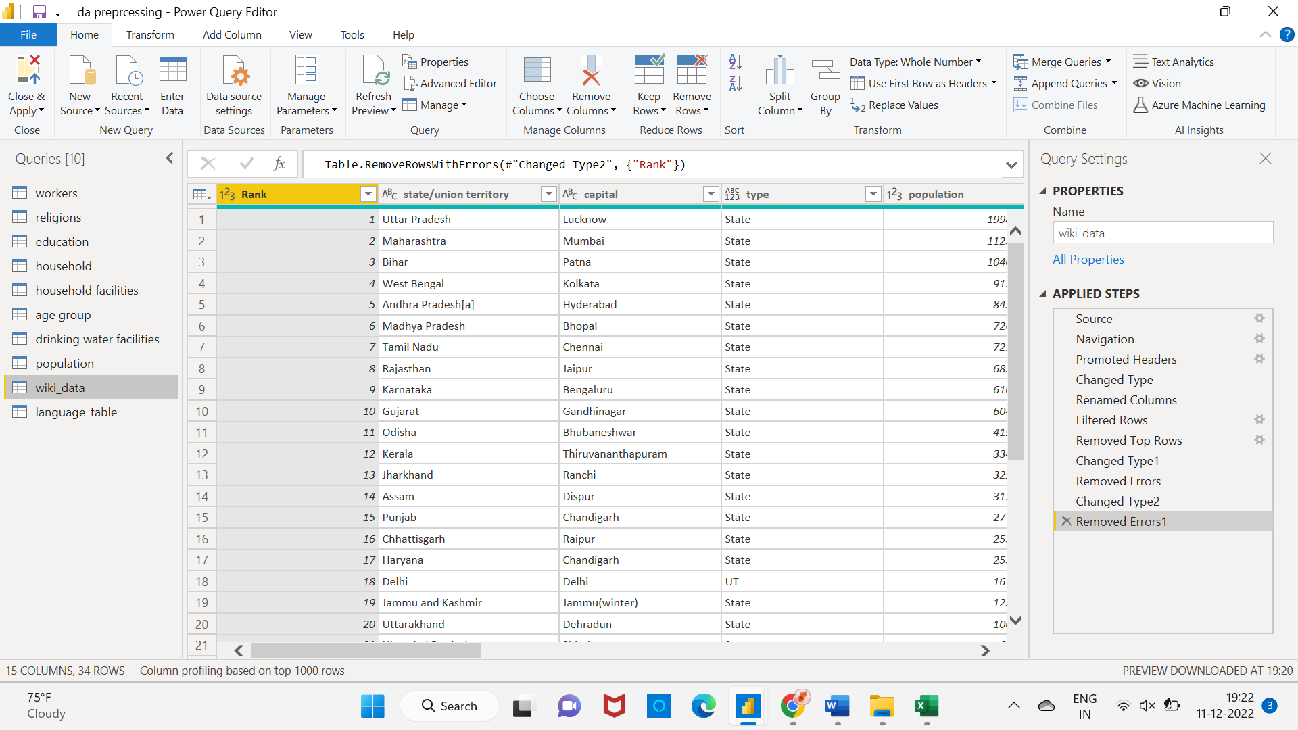

Figure 2.1 wiki_data Table.

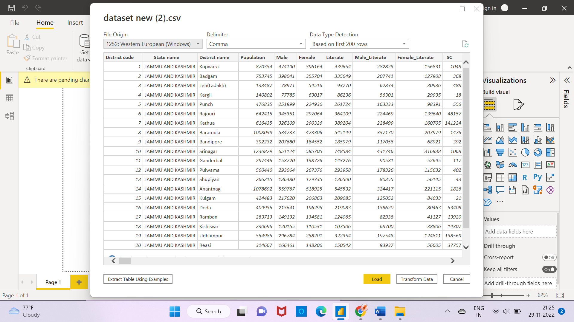

Figure 2.2 Pre-processing

After loading the data, it would look like the below image. It has 118 columns and 640 rows.

Using power query editor, a single dataset containing 118 columns was separated into 8 tables.

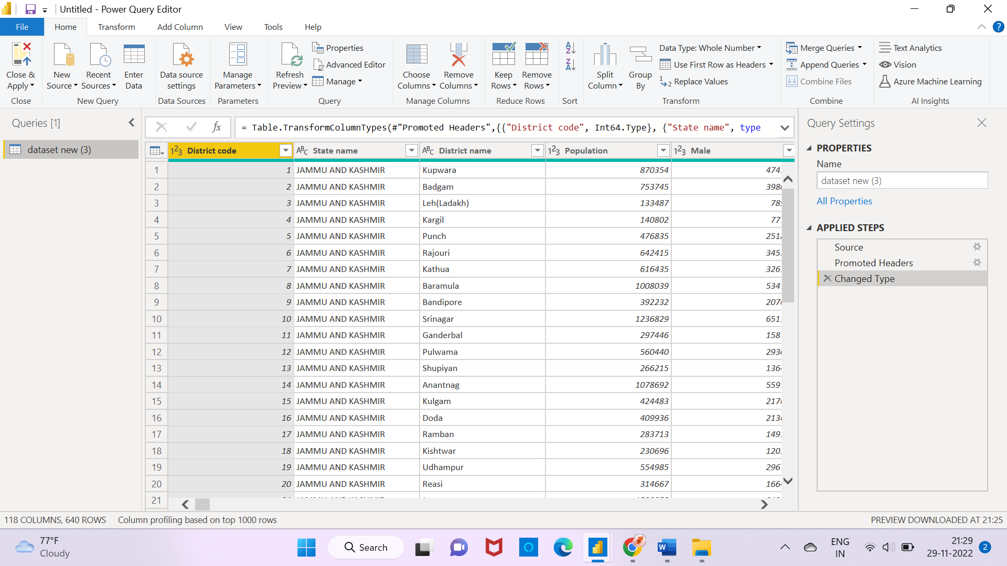

Figure 2.3 Data-types Changed

So, in total the data contains 10 tables.

The tables are named as ‘age,’ ‘drinking water facilities’, ‘education’, ‘household’, ‘household facilities’, ‘wiki_data’, ‘language’, ‘religions’, ‘workers’ and ‘population’ with district code column as a relation between all of them.

Age table and it’s attributes:

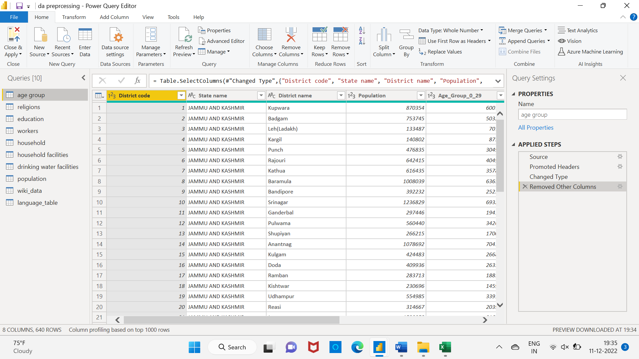

Figure 2.4 Age

Education table:

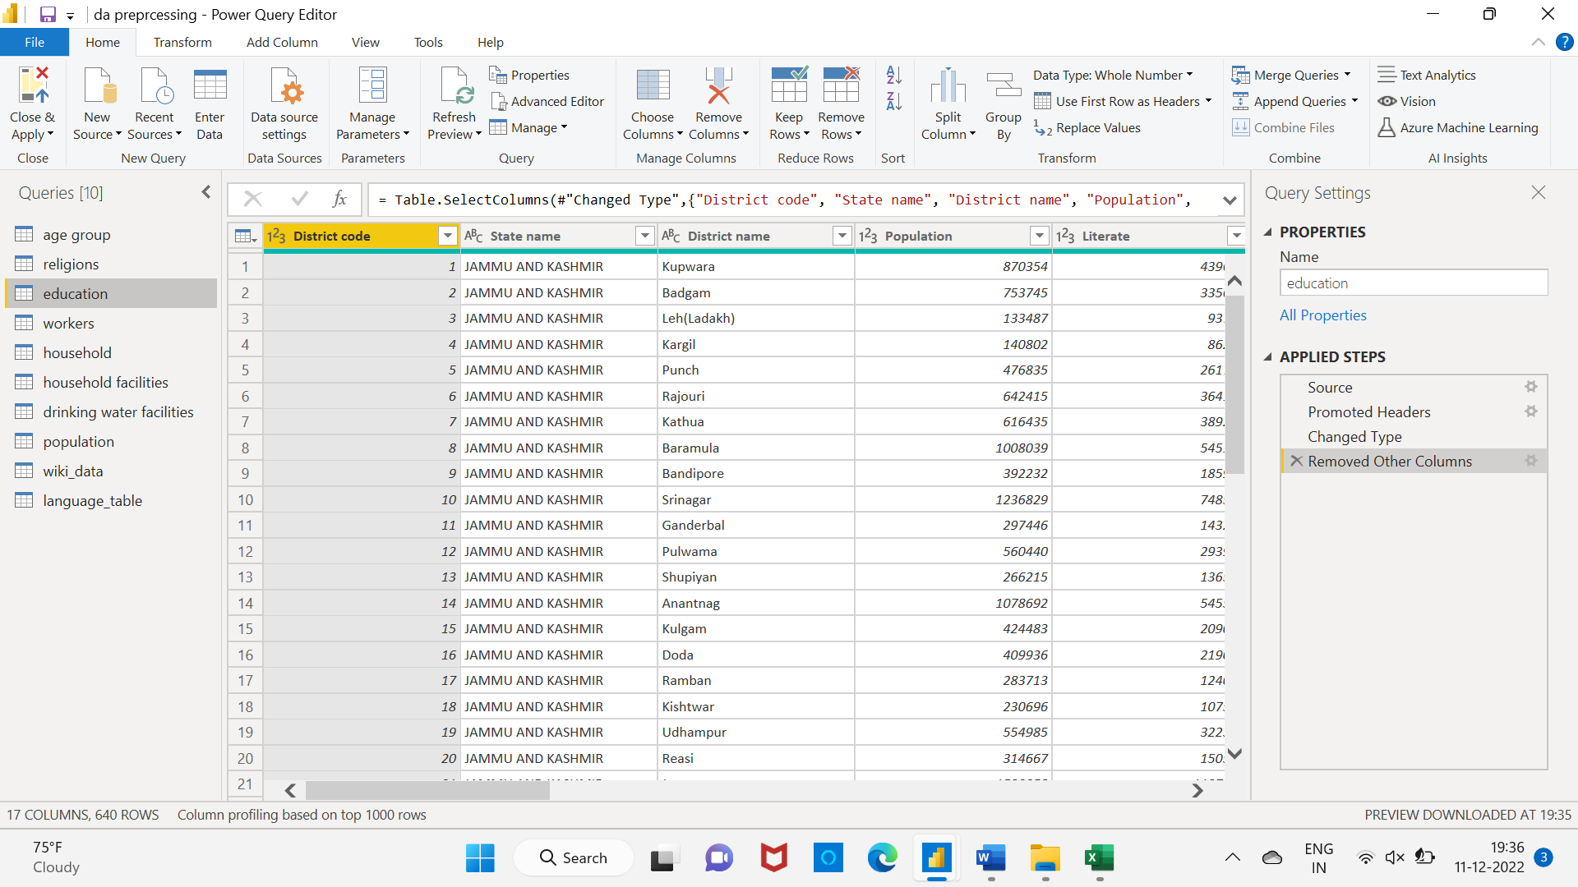

Figure 2.5 Education Table

‘Drinking water facilities’ table:

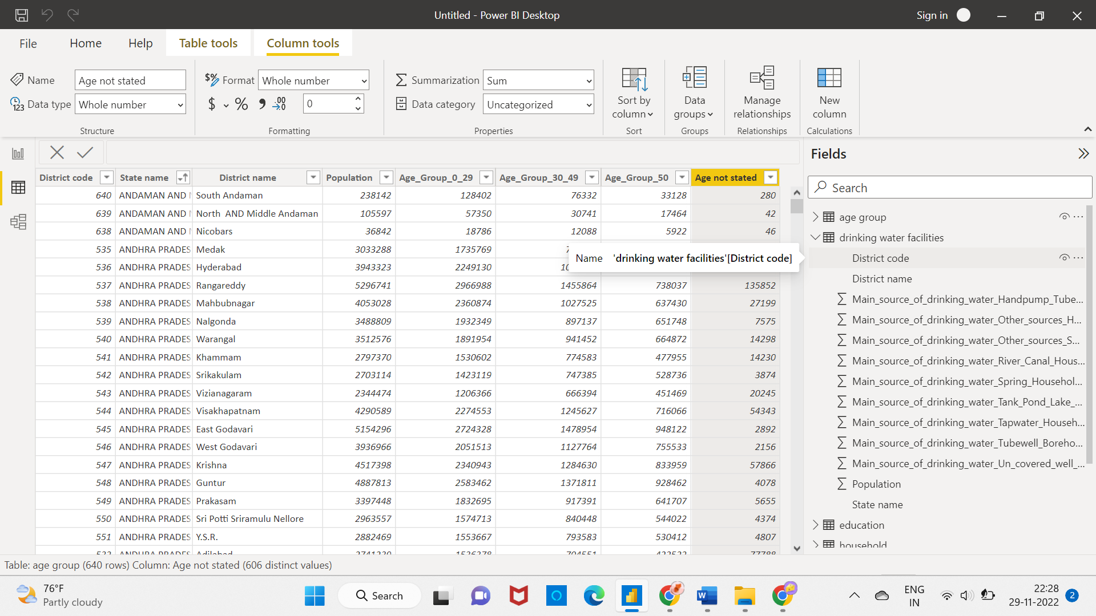

Figure 2.6 Drinking Water facilities

‘household’ table:

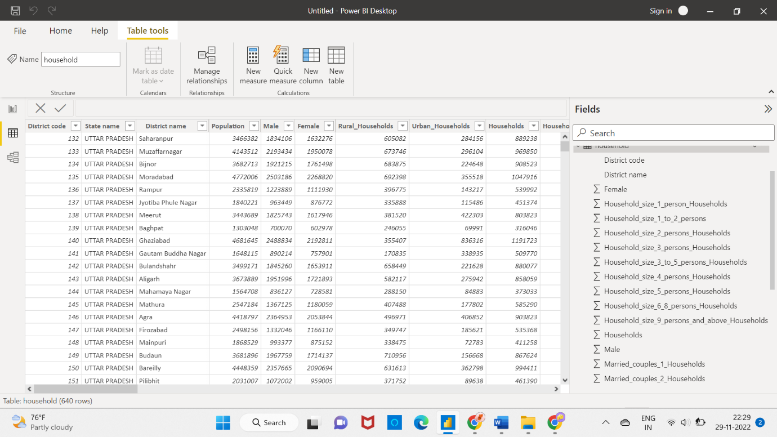

Figure 2.7 Household Table.

‘Household facilities’ table:

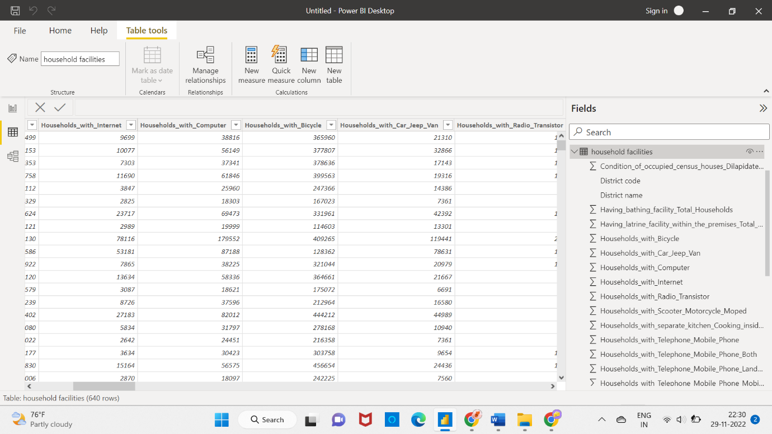

Figure 2.8 House hold facilities.

‘population’ table:

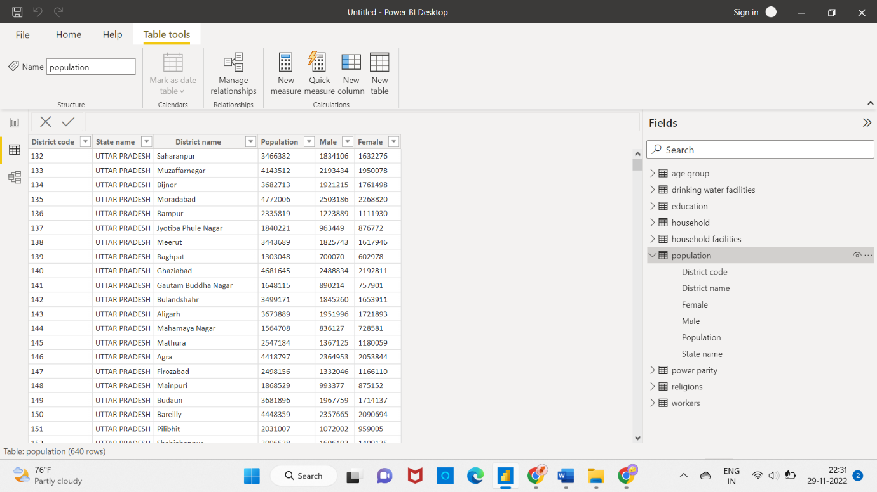

Figure 2.9 Population Table

‘religion’ table:

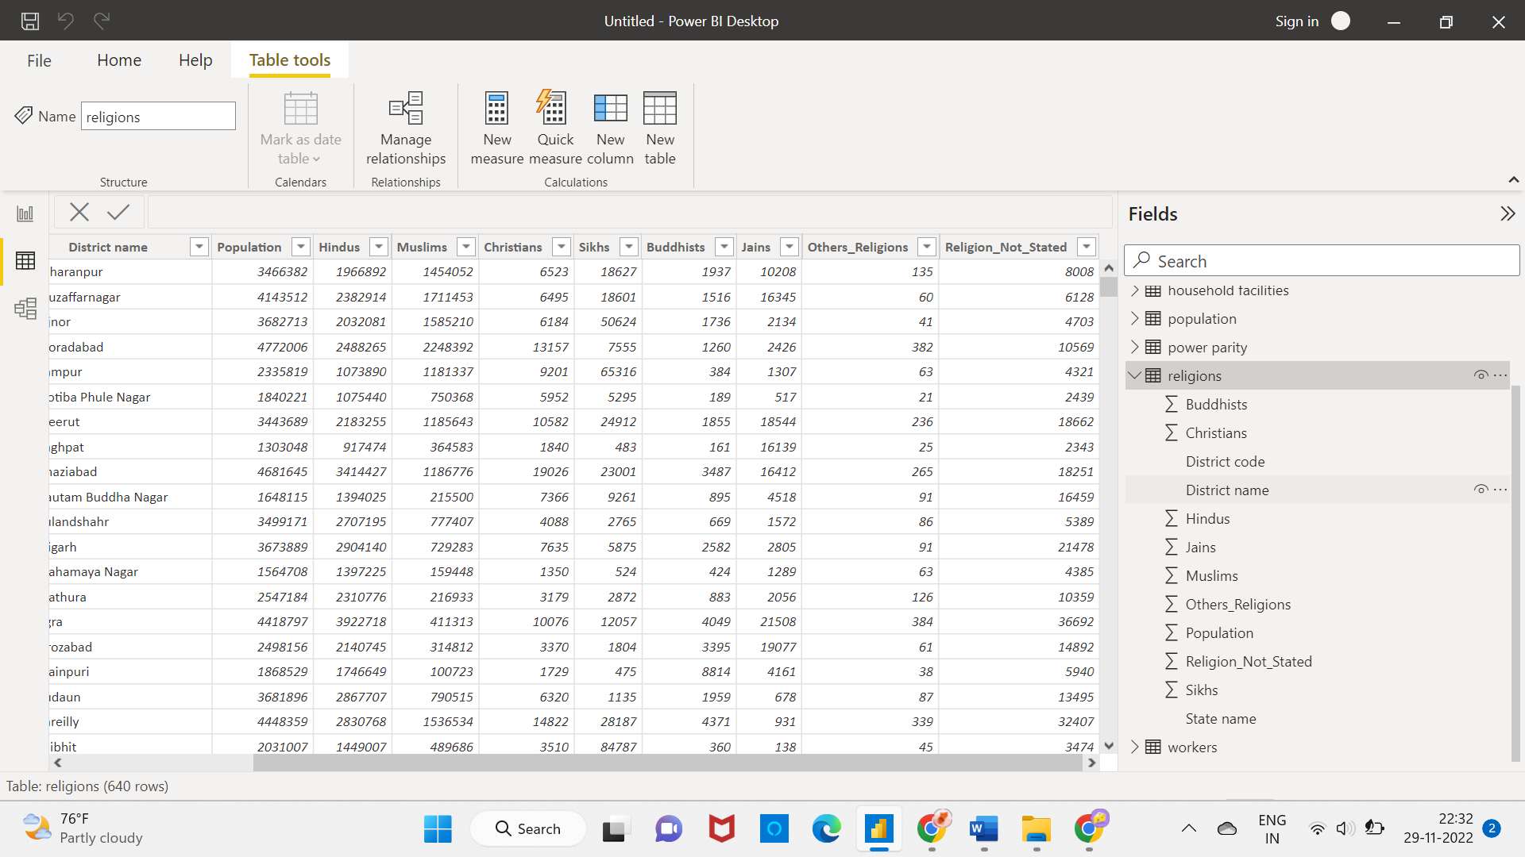

Figure 2.10 Religion Table

‘workers’ table:

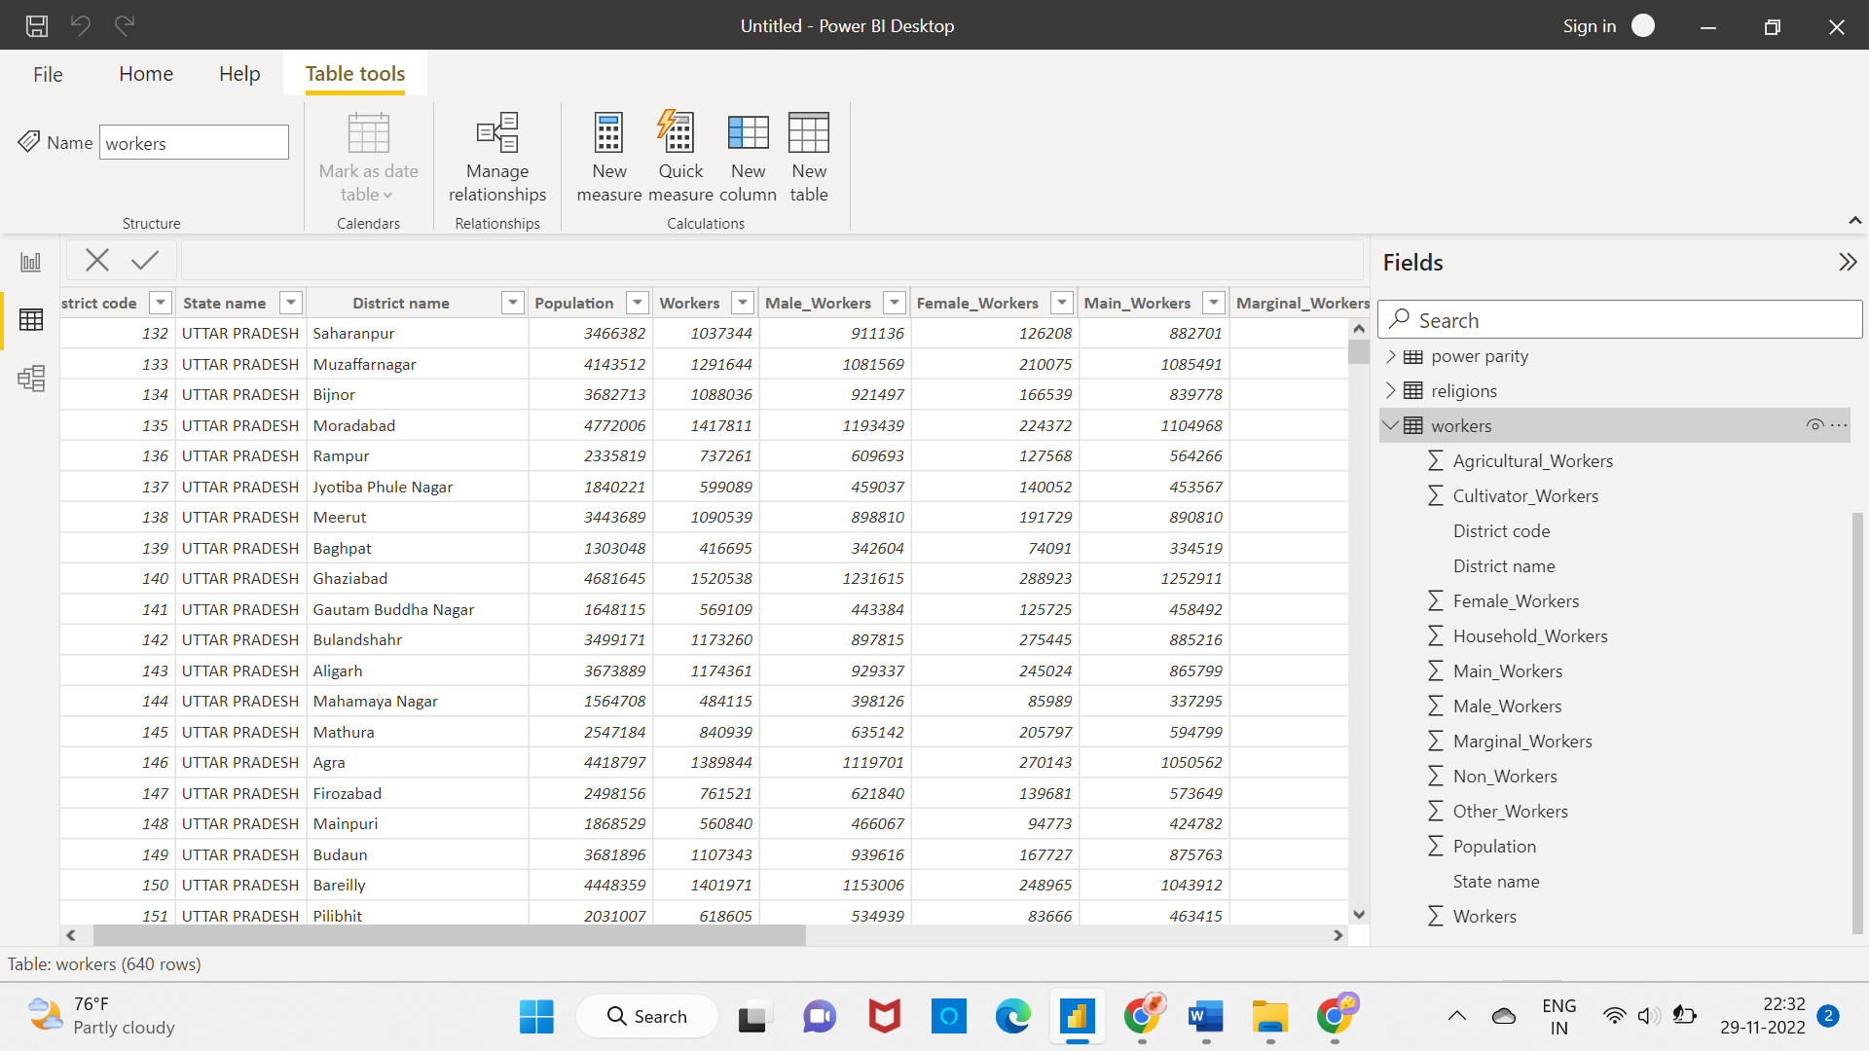

Figure 2.11 Worker’s Table

‘Wiki_data’ table:

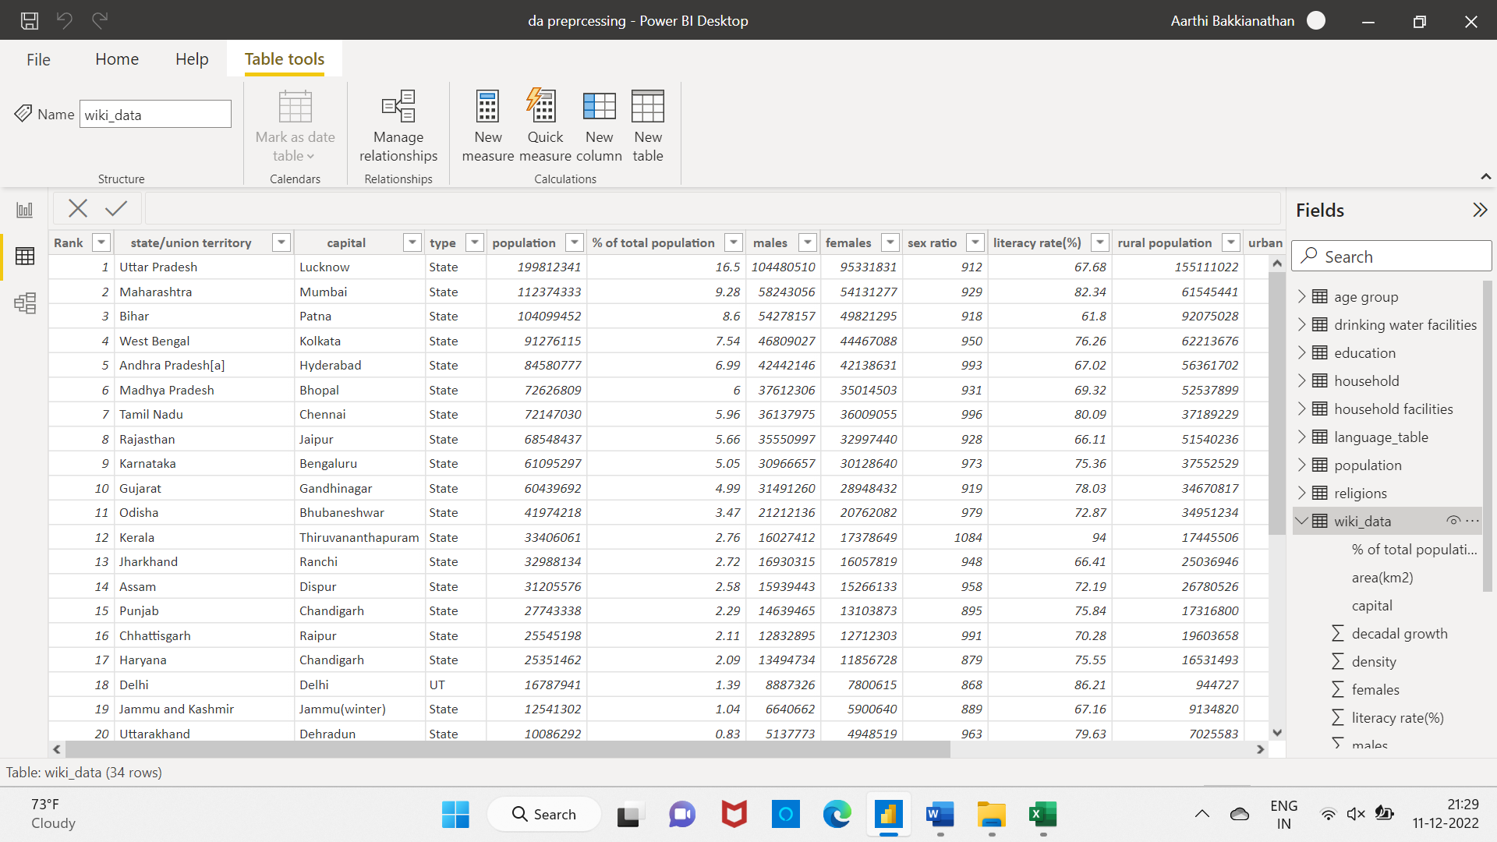figure 2.12 Wiki_data Table.

‘language’ table:

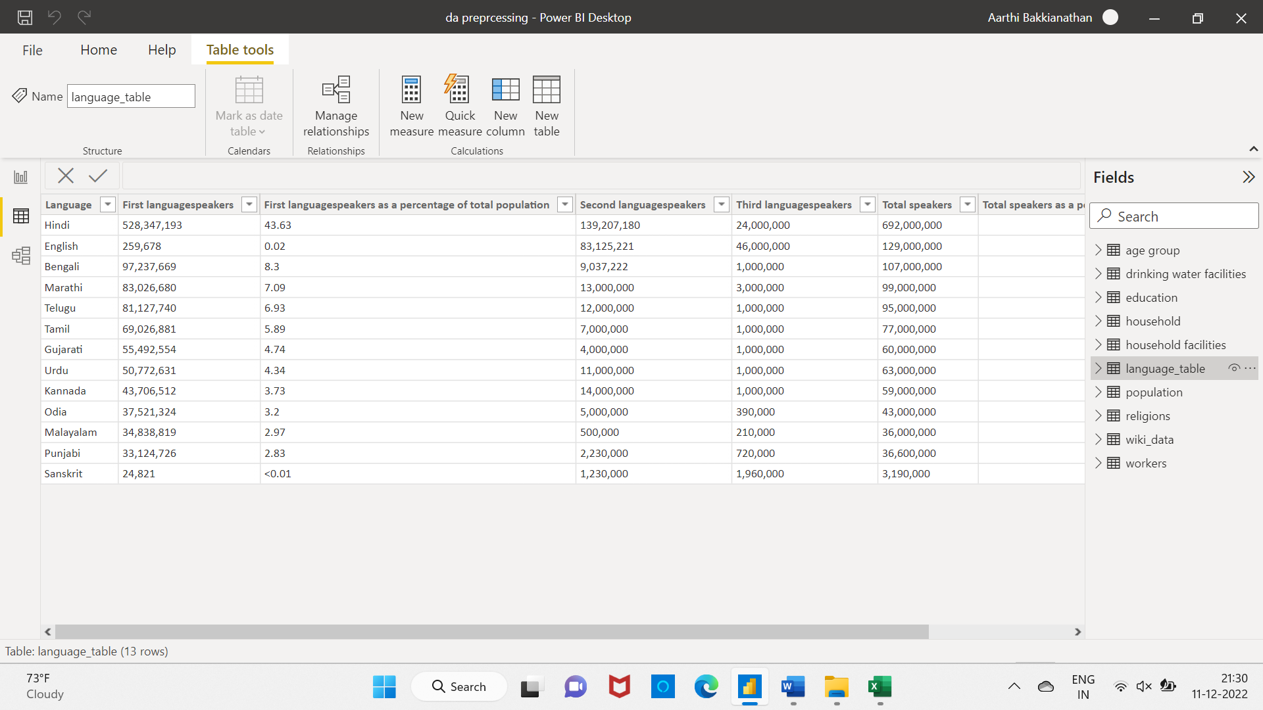

Figure 2.13 Language Table

## 2.2 DATA TRANSFORMATION

Data transformation is the process of converting the values of data to make it suitable for analyzing the data. Python, SQL, etc. are some of the languages used to transform the data. Based on the transformation it can increase the efficiency of business process and it may lead to better decision making. It contains addition and deletion of data based on needs. Filtering, modelling, renaming, aggregation functions, indexing, ordering are some of the processes done in data transformation.

## 2.3 DATA MODELLING

Data modelling is the process to simplify the data and to develop a model for easier understanding the models. Data can be modelled at various level of abstraction. In this process the database is designed according to the requirements of the end users and stakeholders. This is similar to roadmap and a blueprint.

Identifying the entities, identifying the relationship among the entities, mapping the attributes to entities completely, finalize and validate the data model are the basic processes of data modelling.

Three types of data models:

* + - * Conceptual data models
      * Logical data models
      * Physical data models

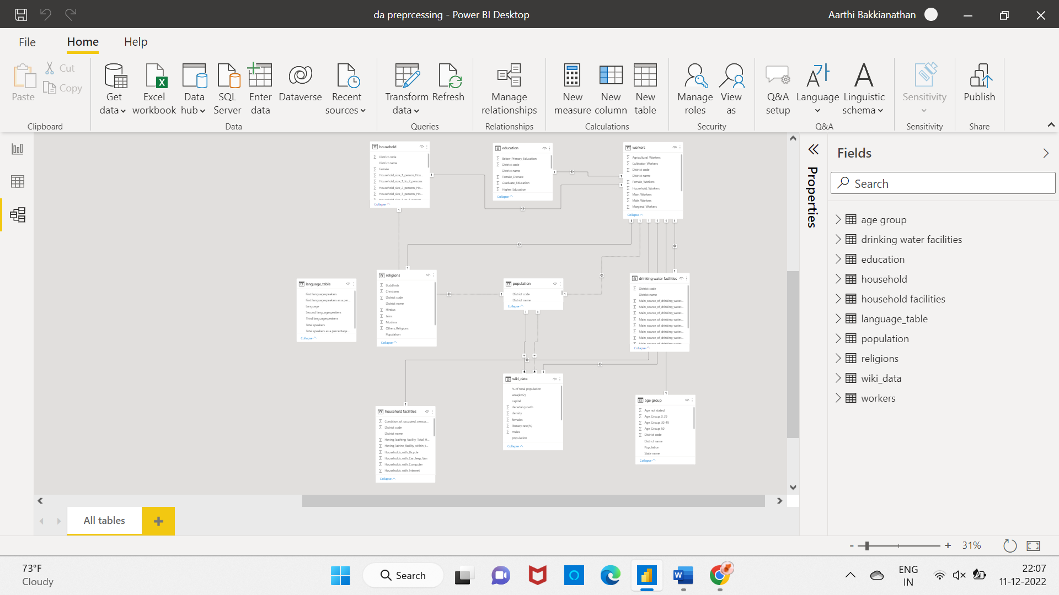

Figure 2.14 Data Model.

The above image is the relationships created and the data model for the Indian population dataset.

There are many one-one relationship between the tables. District code column is the common attribute in this table.

# CHAPTER 3

**DATA ANALYSIS AND INTERPRETATION**

## 3.1 DATA ANALYSIS

Data analysis is the most important step for a company/business as it gives many insights and inference based on which the business procedures can be changed and the possible outcomes may be noted, these all result in the overall performance of a company/business product.

Analysis of data can be done by creating charts, comparing various attributes and analyzing the previously collected data/past data for making decisions in future based on it. R, SAS, SQL, PYTHON, MALTLAB and JAVA are some of the data analysis tools. These help to analyze the relation between the attributes and to identify the trends and patterns. Some of the methods are text analysis, statistical analysis, predictive analysis, etc.

**The questions prepared for this dataset are:**

1. What is the total number of districts in India according to 2011 census?

2. What is the total population of India according to 2011 census?

3. Name the top 10 states by highest population.

4. Which state has the highest and lowest urban population?

5. Which state has the highest and lowest rural population?

6. Population by Union Territories.

7. What is the total density of India?

8. Which state has the highest and least literacy rate?

9. Compare the Sex ratio between each state.

10. Compare the religion status.

11. Which state has the highest female and male workers?

12. Comparison of urban and rural population for each state using slicer.

13. Draw a graph to show the sum of area for each state.

14. Analyze the decadal growth of Indian population.

15. Define the total population in age groups.

16. What is the highest spoken language in India?

17. Compare the availability and non-availability of latrine facilities in India.

18. Which type of vehicle is highly available among all the households?

19. Classify the population according to the workers.

20. The total number of states and union territories?

21. what are the top 5 populated districts?

22. Average count of females and males?

## 3.2 PUBLISHING DASHBOARD

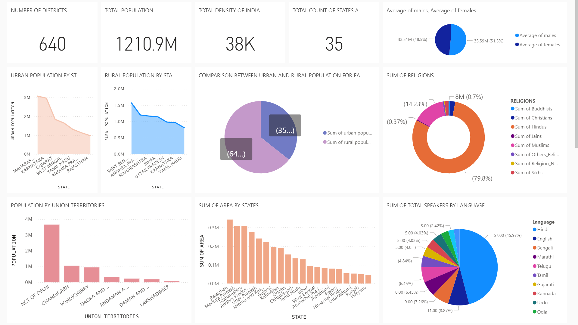

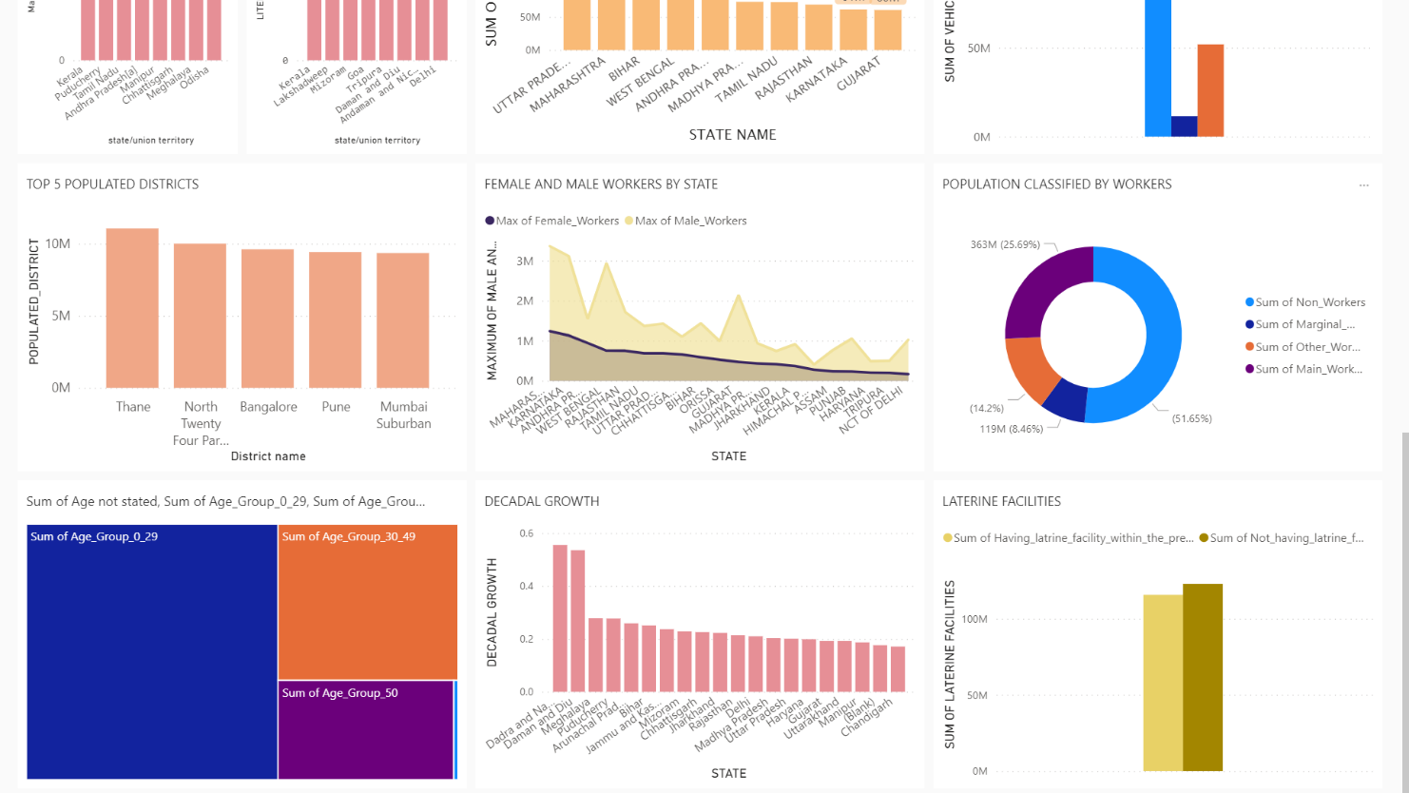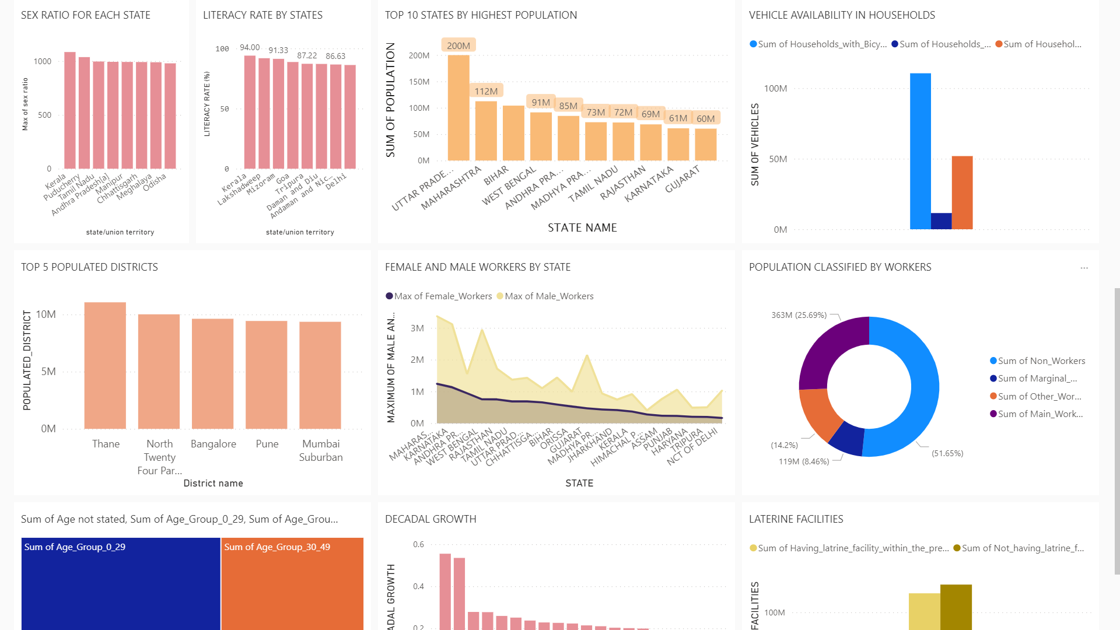

1. What is the total number of districts?

steps

Create a new measure with the formula as “no_of_districts = COUNT (‘population’ [District name])”

Insert a card visualization to visualise the number of districts.

output

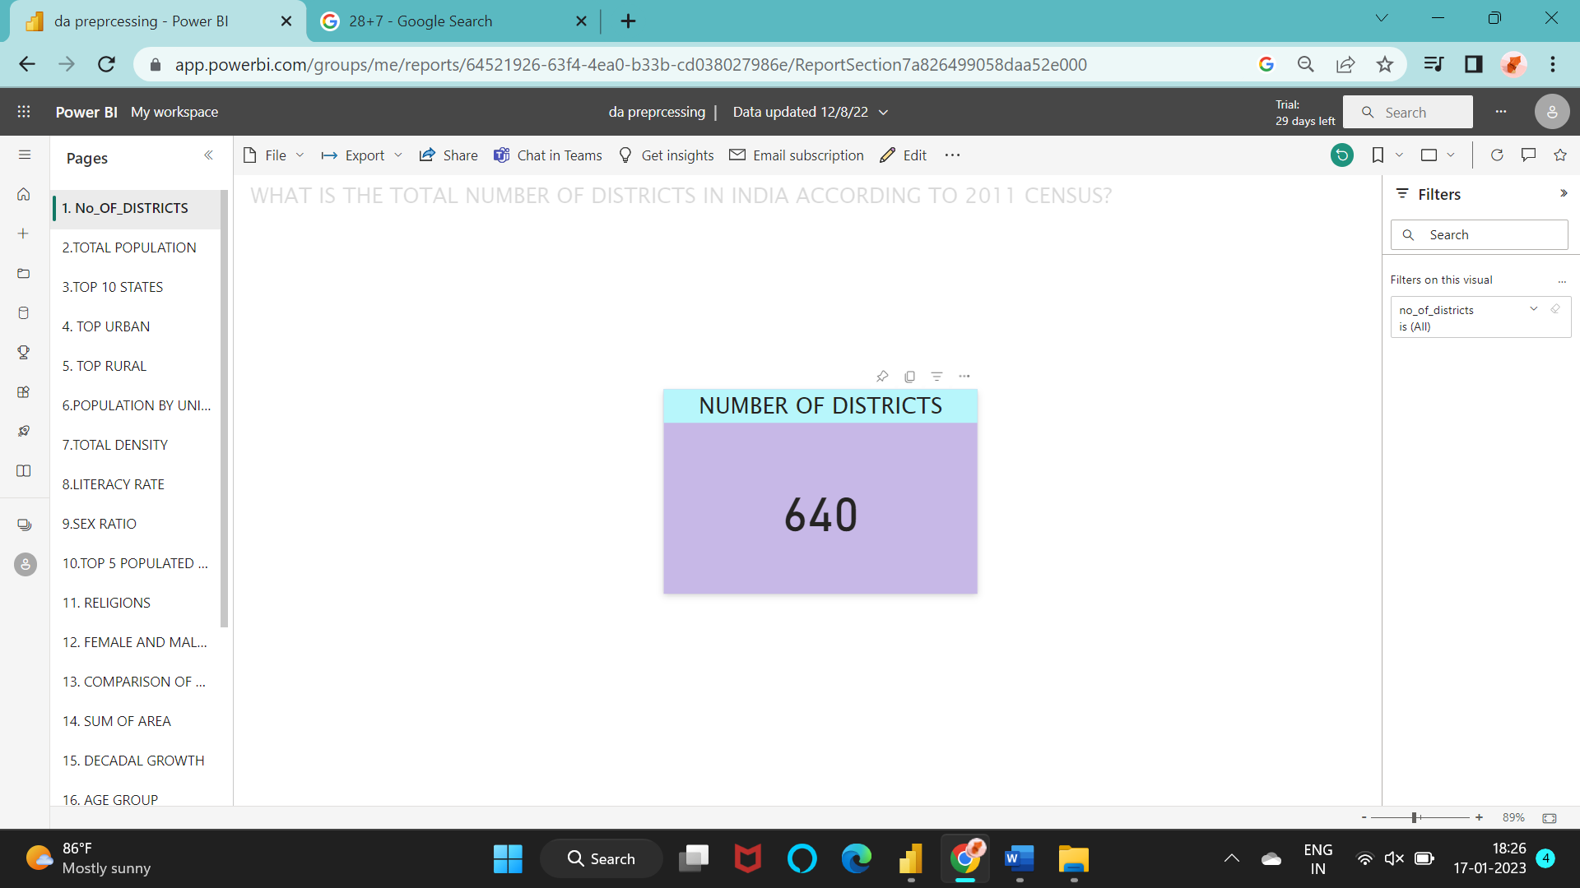

Figure 3.1 Total number of districts

2. What is the total population of India according to 2011 census?

STEPS:

Create a new measure to find the total population.

TOTAL_POP = SUM([Population])

Use the ‘card’ to visualize it.

OUTPUT:

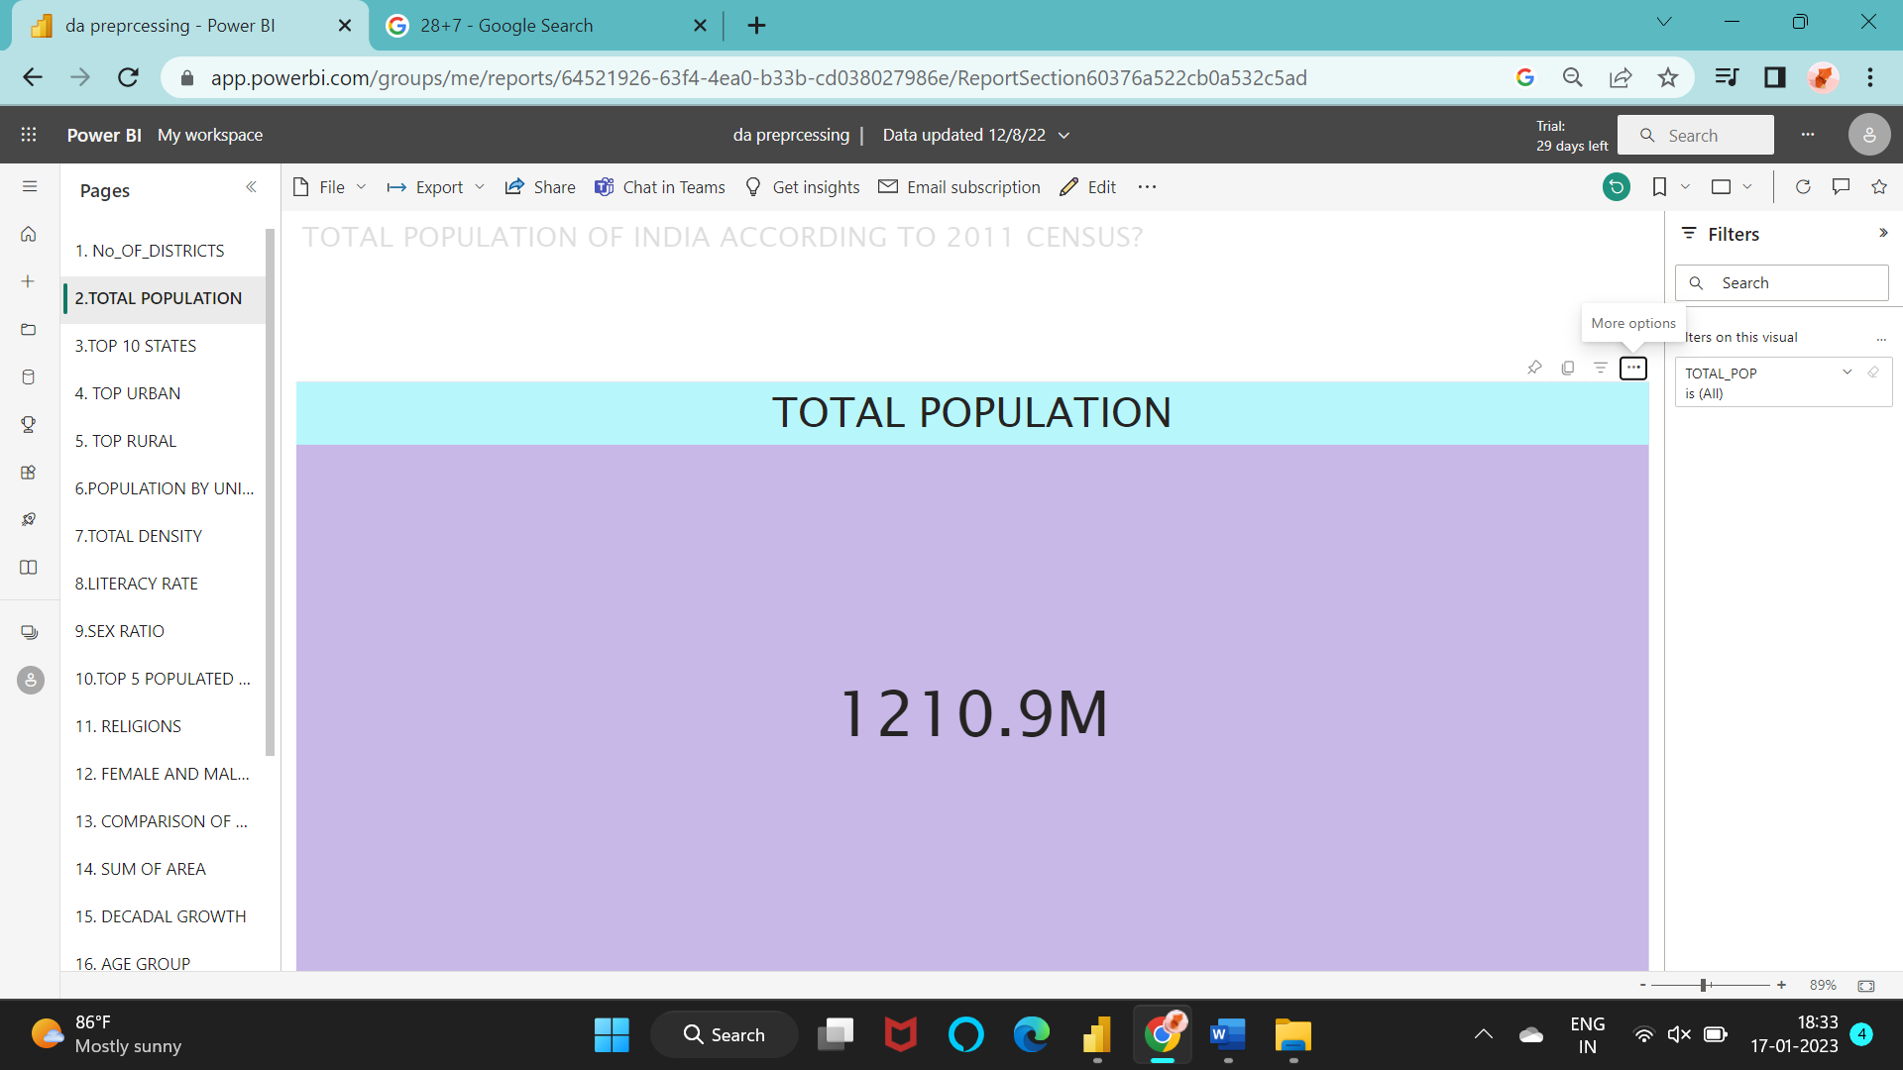

Figure 3.2 Total population

3. Name the top 10 states by highest population.

STEPS:

To create a clustered column chart and add the ‘state name’ in X-axis and ‘Sum of population’ in Y-axis.

Add the filter named ‘TOP N’ and to find the top 10 states with highest population.

OUTPUT:

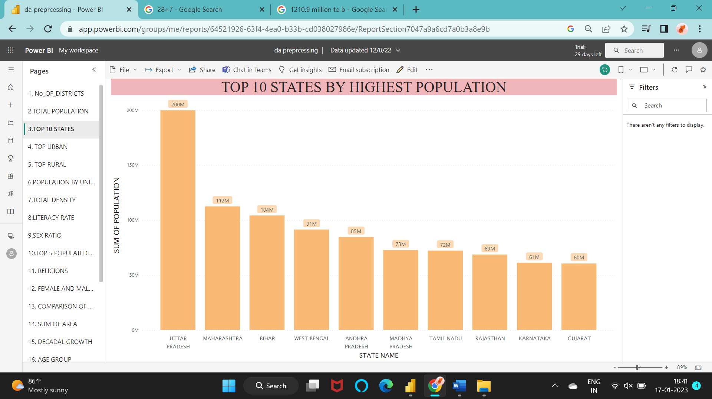

Figure 3.3 Top 10 states by highest population

4. Which state has the highest and lowest urban population?

STEPS:

Draw an area chart with X-axis as ‘state name’ and Y-axis as ‘Top_urban’ measure created.

TOP_URBAN = MAX(‘household’[Urban_Households])

OUTPUT:

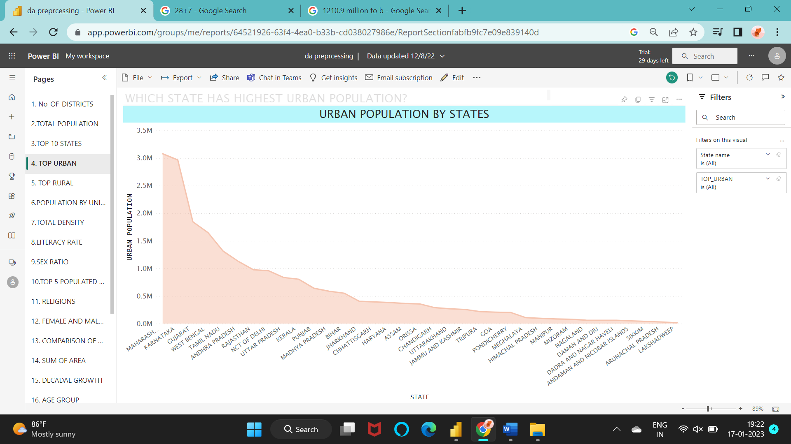

Figure 3.4 Urban population by states

5. Which state has the highest and lowest rural population?

STEPS:

Create an area chart with the X-axis and Y-axis as ‘state name’ and ‘top_rural’ measure respectively.

TOP_RURAL = CALCULATE(MAX(‘household’[Rural_Households]),’household’[Population])

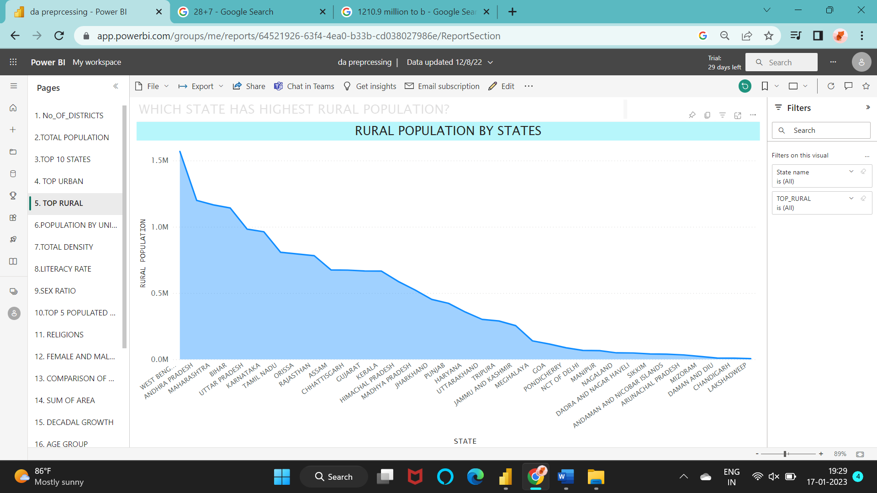OUTPUT:

Figure 3.5 Rural population by states

6. Population by Union Territories.

STEPS:

Create a clustered column chart with X-axis as ‘state name’ and Y-axis as ‘Max of population’.

Apply filter to filter out all the union territories and display them.

OUTPUT:

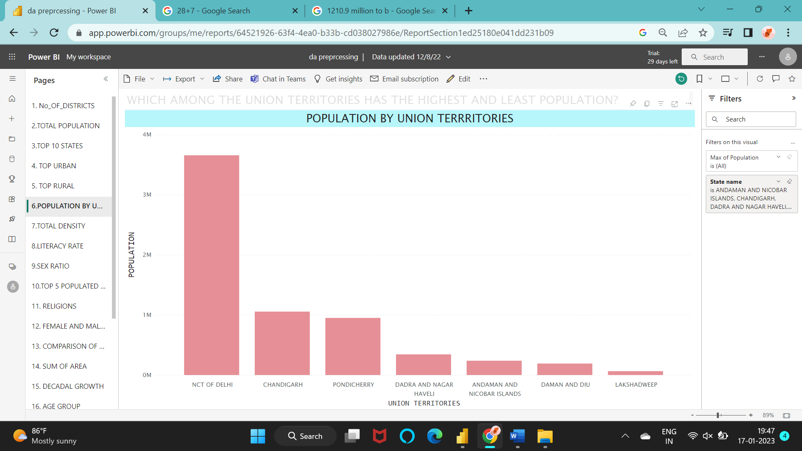

Figure 3.6 Population by union territories

7. What is the total density of India?

STEPS:

Create a measure total_density = SUM(‘wiki_data’[density]).

Then insert it in the fields area under card visualizations.

OUTPUT:

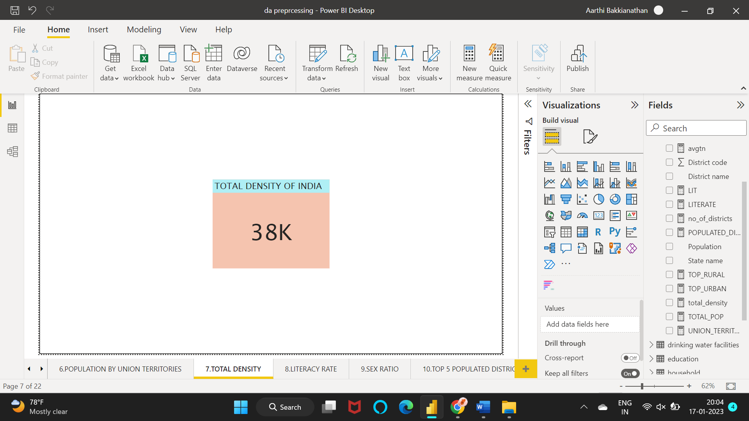

Figure 3.7 Total density of India

8. Which state has the highest and least literacy rate?

STEPS:

Create a clustered column chart.

Insert the columns ‘state name’ and ‘max of literacy rates (%)’ in X-axis and Y-axis respectively to compare the literacy rates of each state.

OUTPUT:

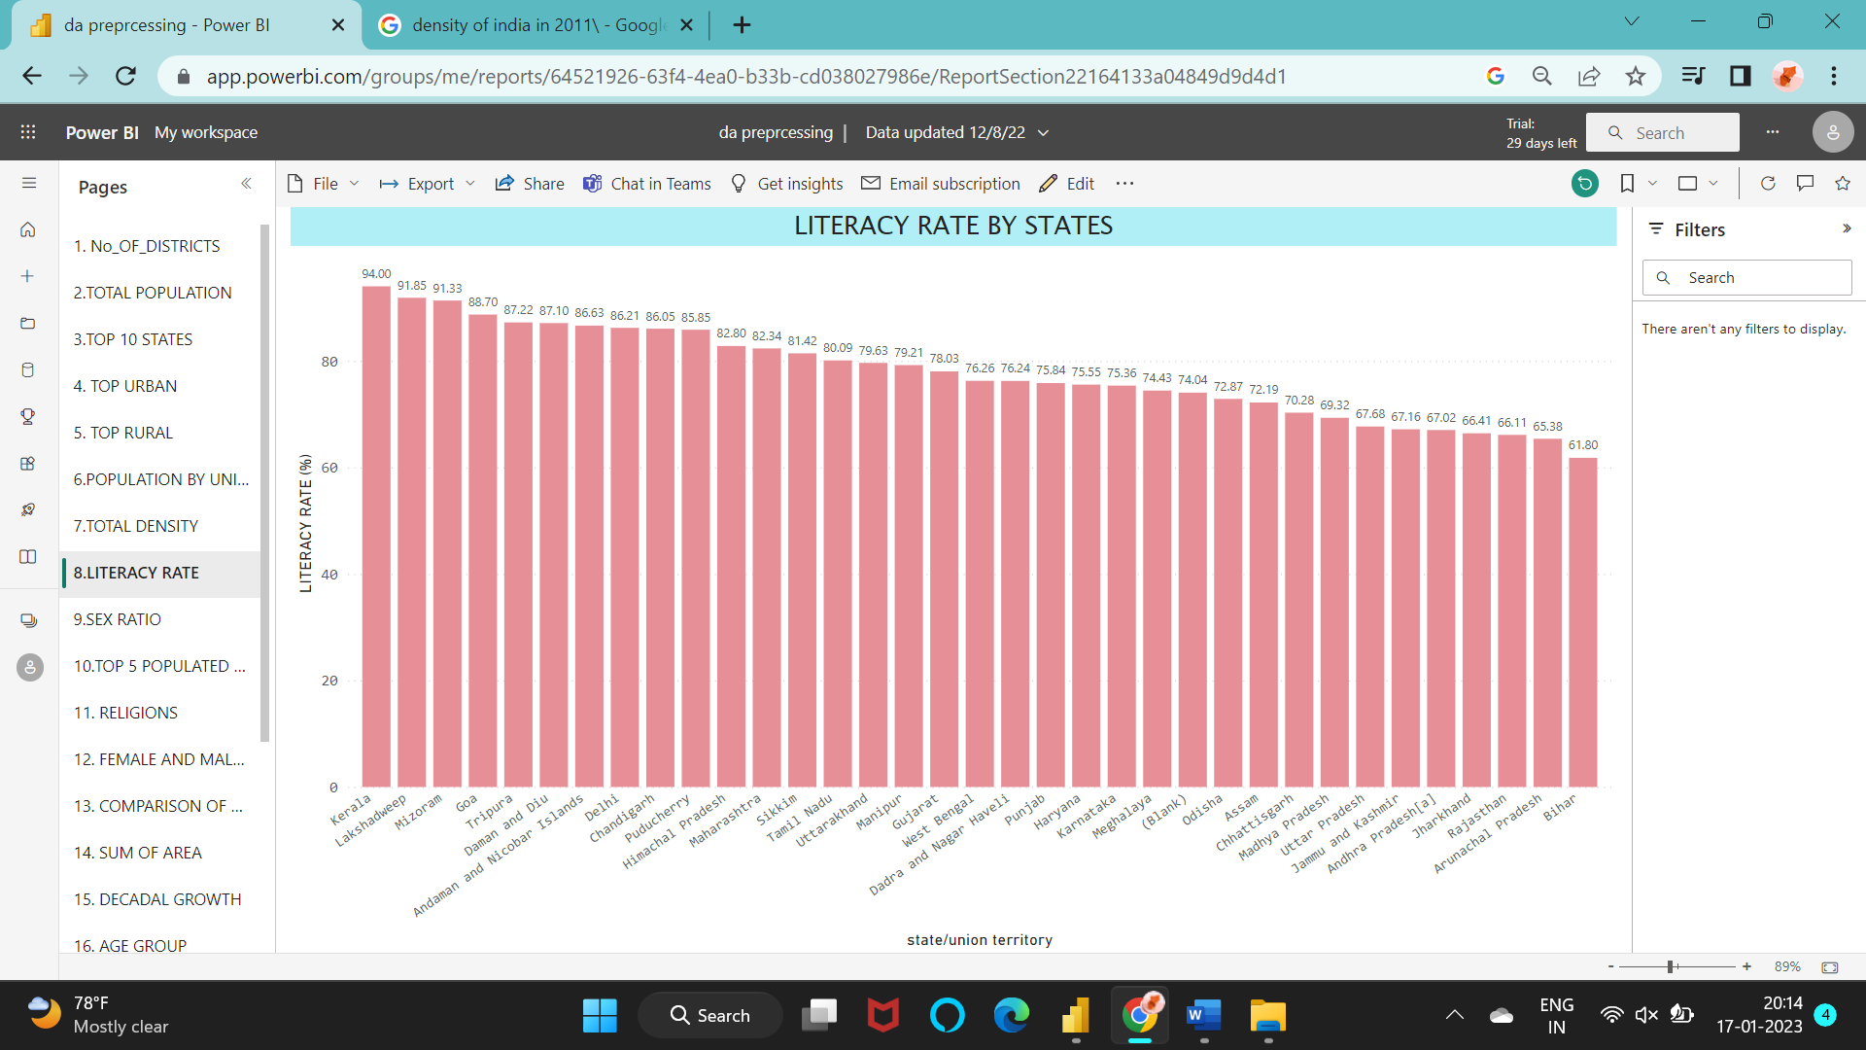

Figure 3.8 Literacy rate by states

9. Compare the Sex ratio between each state/union territories.

STEPS:

Draw a clustered column chart.

Drag and drop the columns ‘state name’ and ‘max of sex ratio’ in X-axis and Y-axis respectively.

OUTPUT:

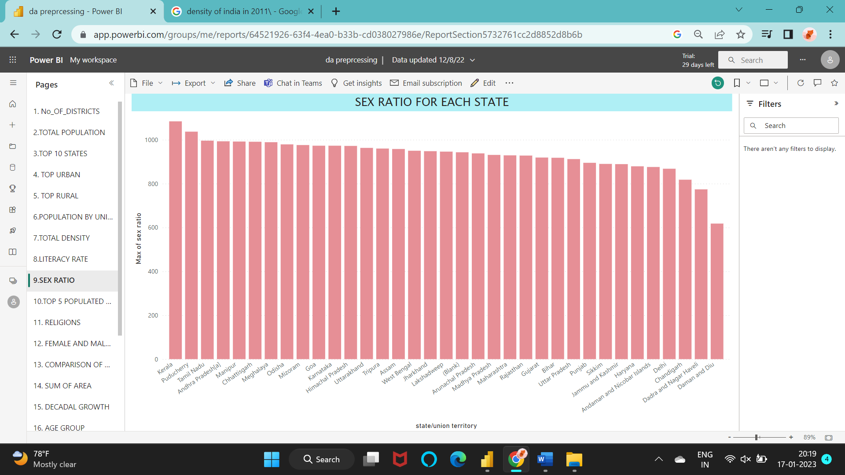

Figure 3.9 Sex ratio for each state

10. Compare the religion status.

STEPS:

Create a donut chart and add the columns in the values field.

OUTPUT:

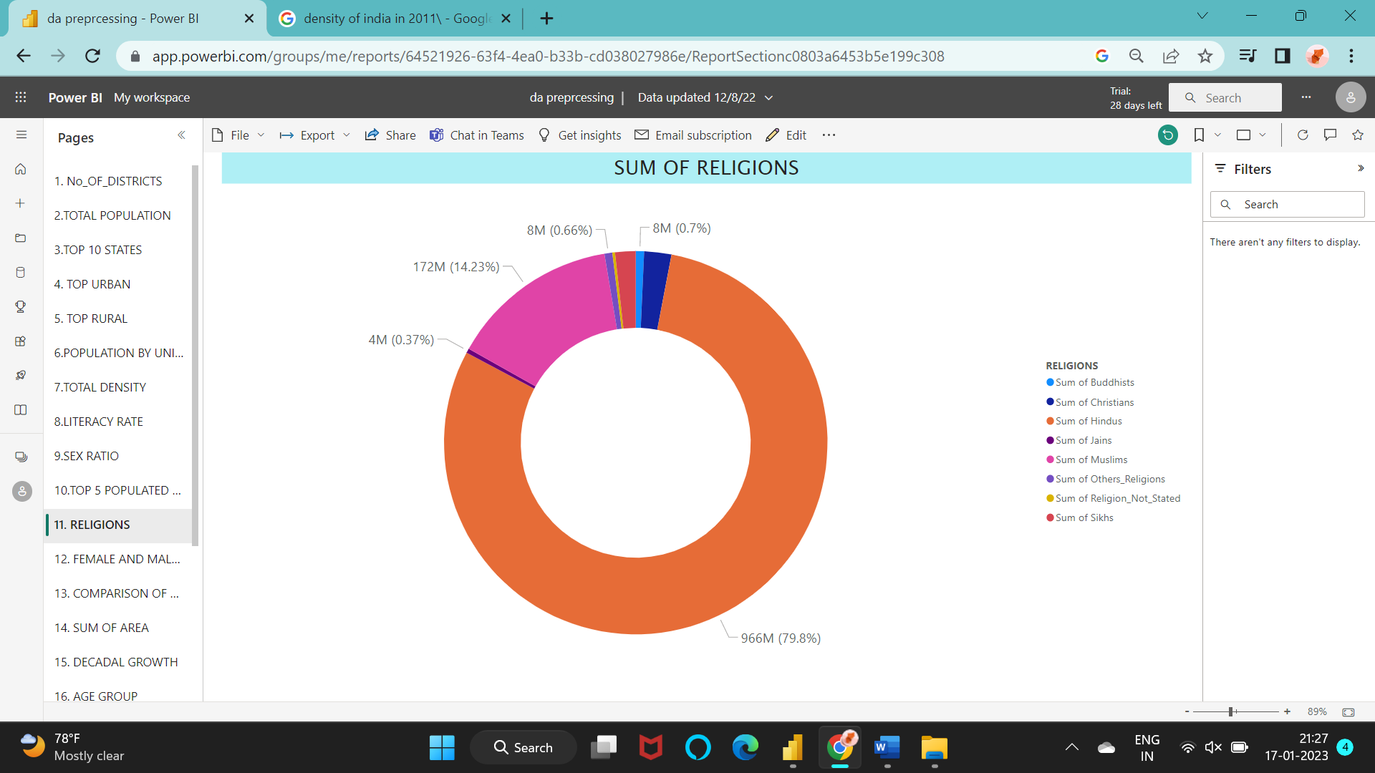

Figure 3.10 Sum of religions

11. Which state has the highest female and male workers?

STEPS:

Create an area chart and drag and drop the columns ‘state name’ in X-axis and ‘max of female workers’ and ‘max of male workers’ under Y-axis.

Then compare the ratio of female workers to male workers in each state.

OUTPUT:

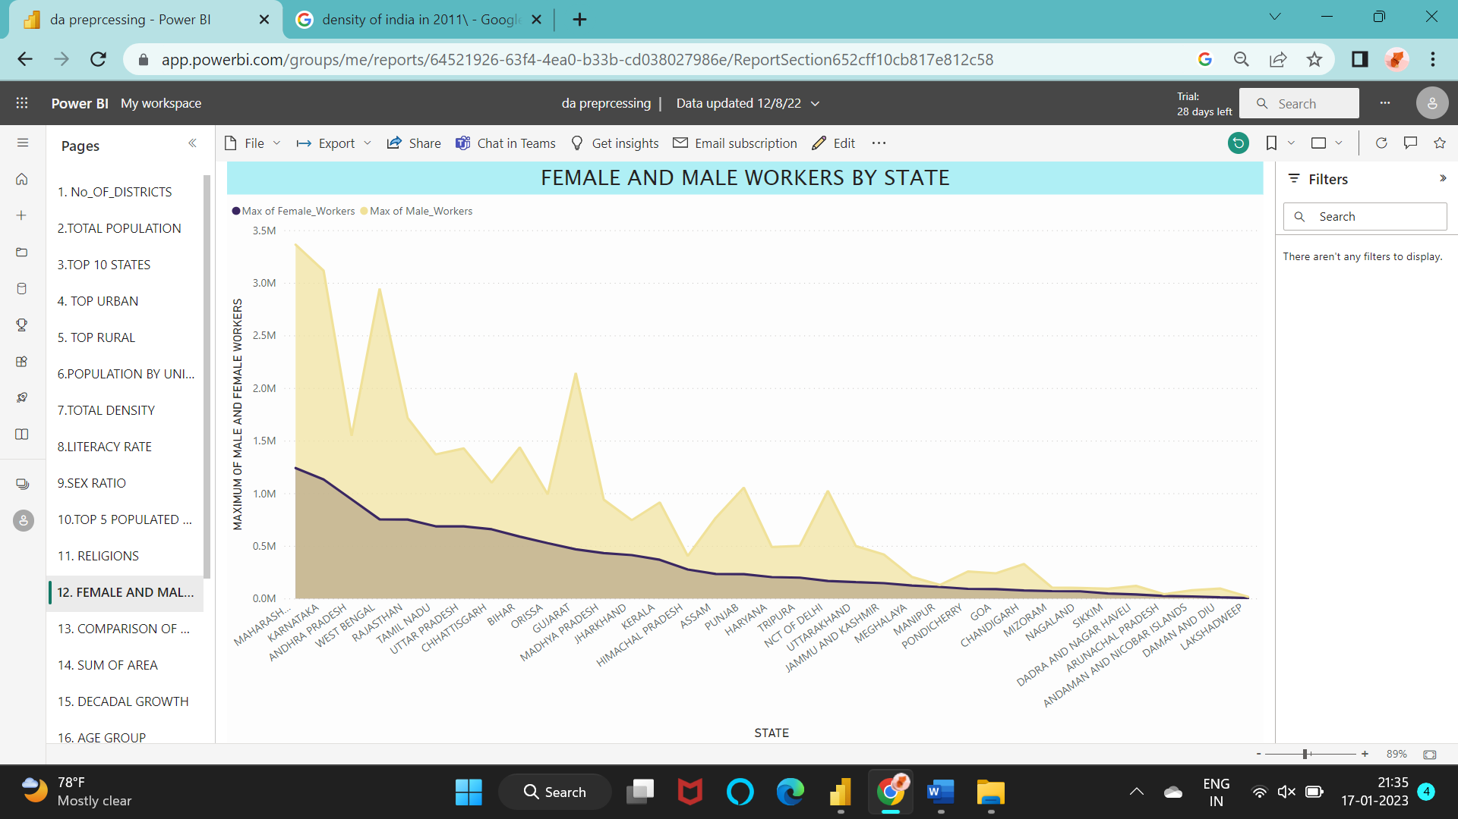

Figure 3.11 Female and male workers by state

12. Comparison of urban and rural population for each state using slicer.

STEPS:

Draw a chart and insert the columns ‘sum of urban population’ and ‘sum of rural population’ in values.

Insert a slicer next to it with the field as ‘state/union territory’.

When selecting the particular state/union territory the pie chart values change according to the selected state/union territory.

OUTPUT:

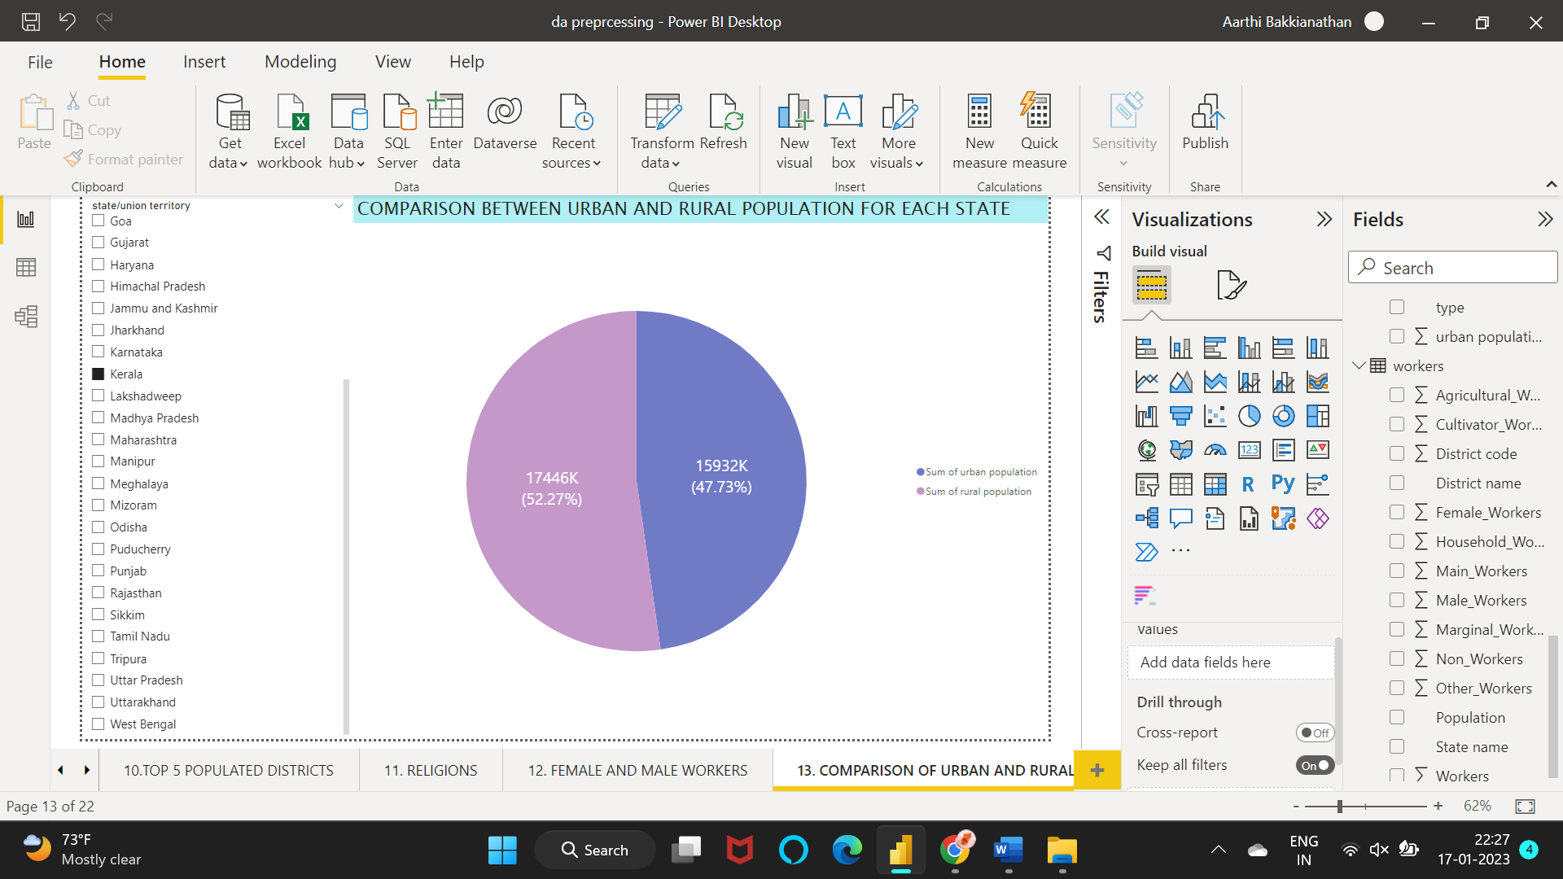

Figure 3.12 Comparison between urban and rural population for each state

13. Draw a graph to show the sum of area for each state.

STEPS:

Create a clustered column chart with X-axis as ‘state name’ and Y-axis as ‘sum of area (km2)’.

OUTPUT:

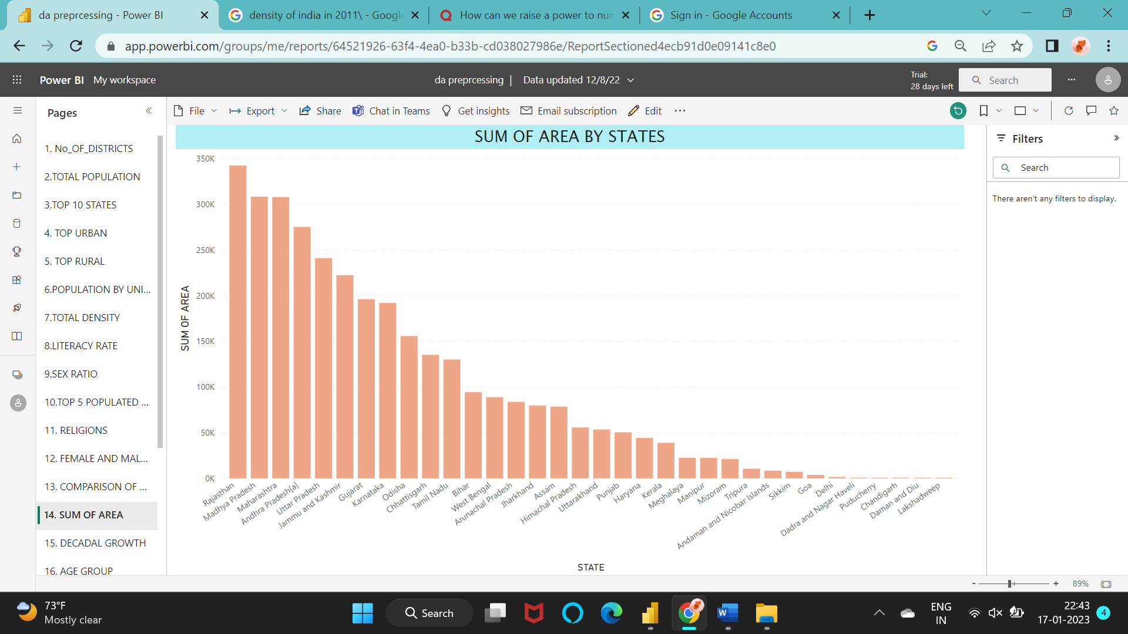

Figure 3.13 Sum of area by states

14. Analyze the decadal growth of Indian population.

STEPS:

Create a clustered column chart with X-axis as ‘state/union territory’ and Y-axis as ‘max of decadal growth’.

OUTPUT:

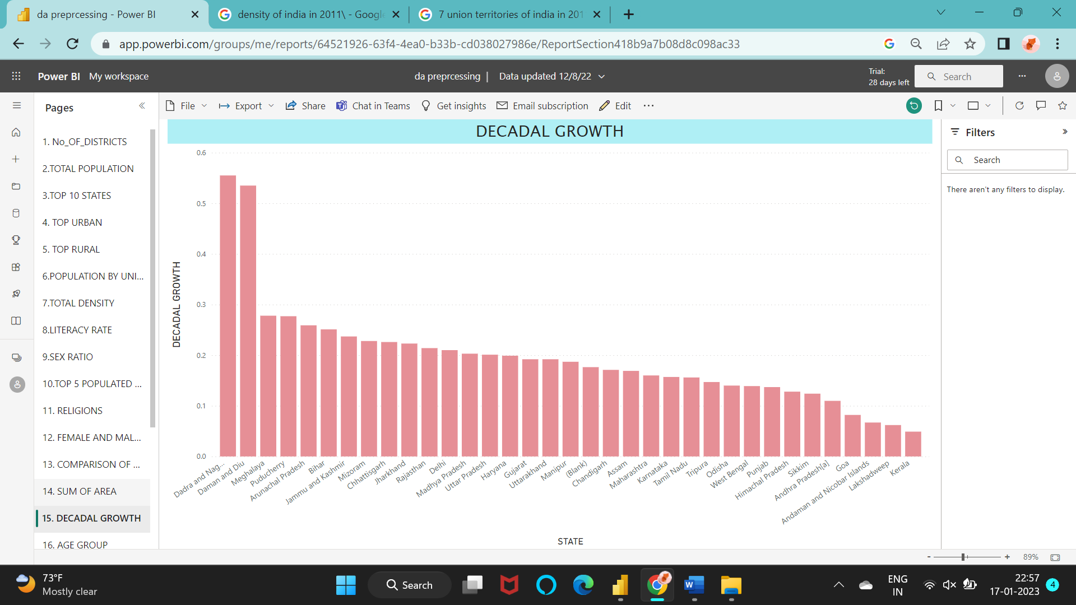

Figure 3.14 Decadal growth

15. Define the total population in age groups.

STEPS:

Choose the tree map from visualizations and add the columns to the values.

OUTPUT:

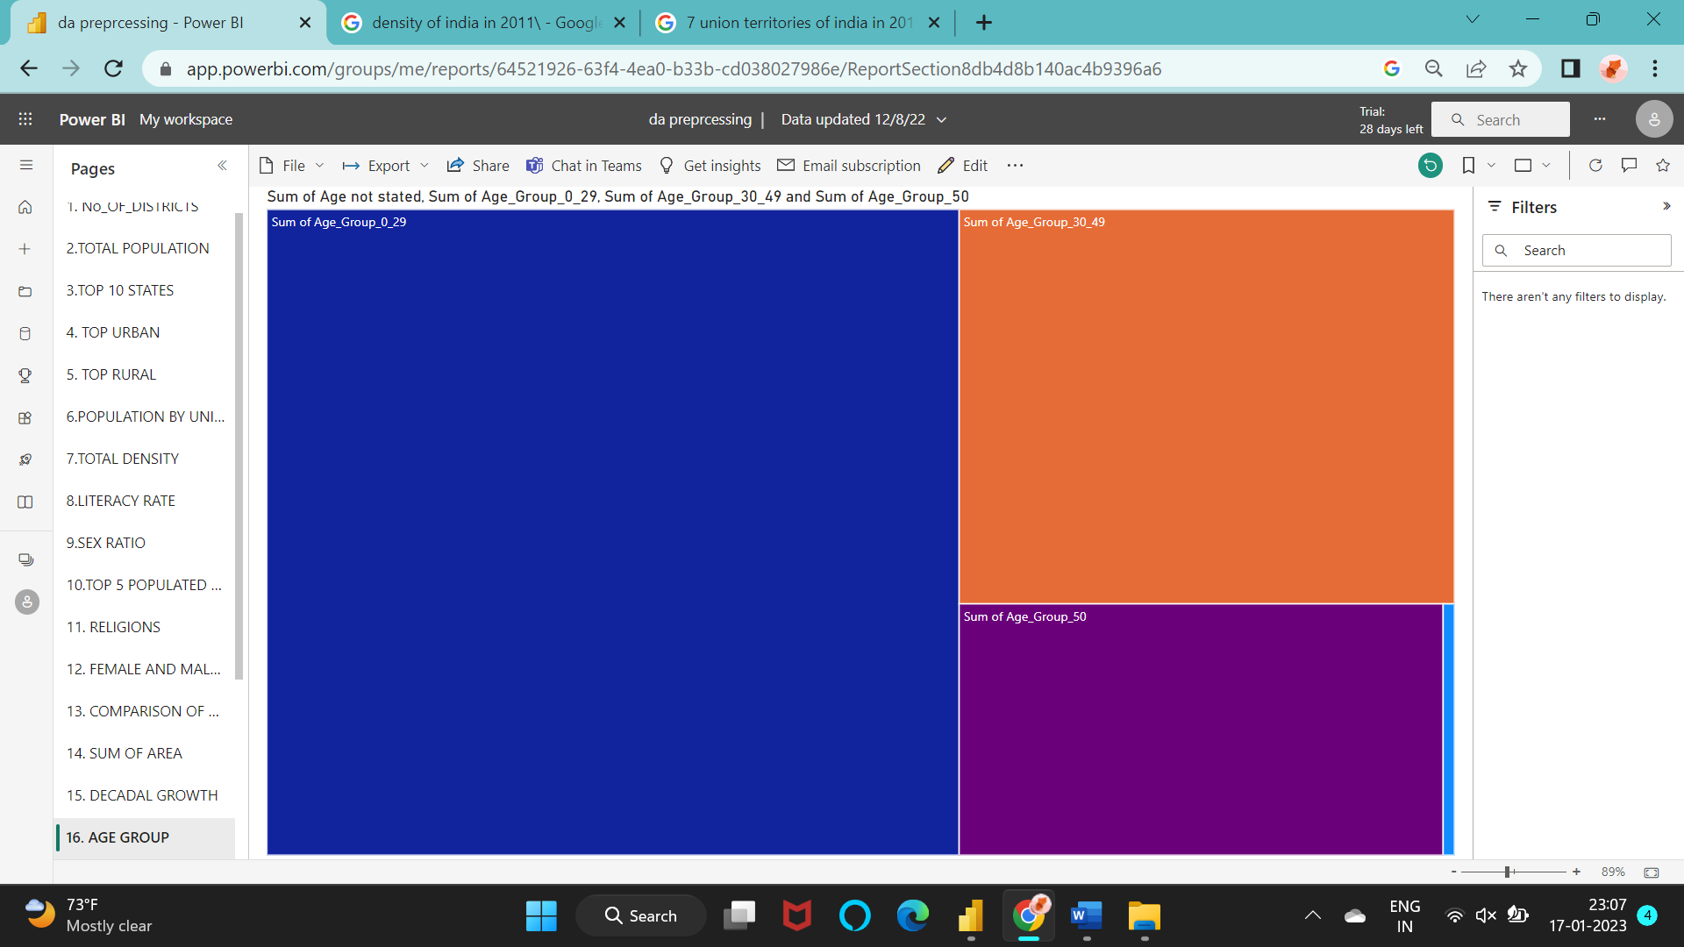

Figure 3.15 Total population under age group

16. What is the highest spoken language in India?

STEPS:

Draw a pie chart to compare all the spoken languages.

Under legend drag and drop the language and under values drag and drop the sum of total speakers.

OUTPUT:

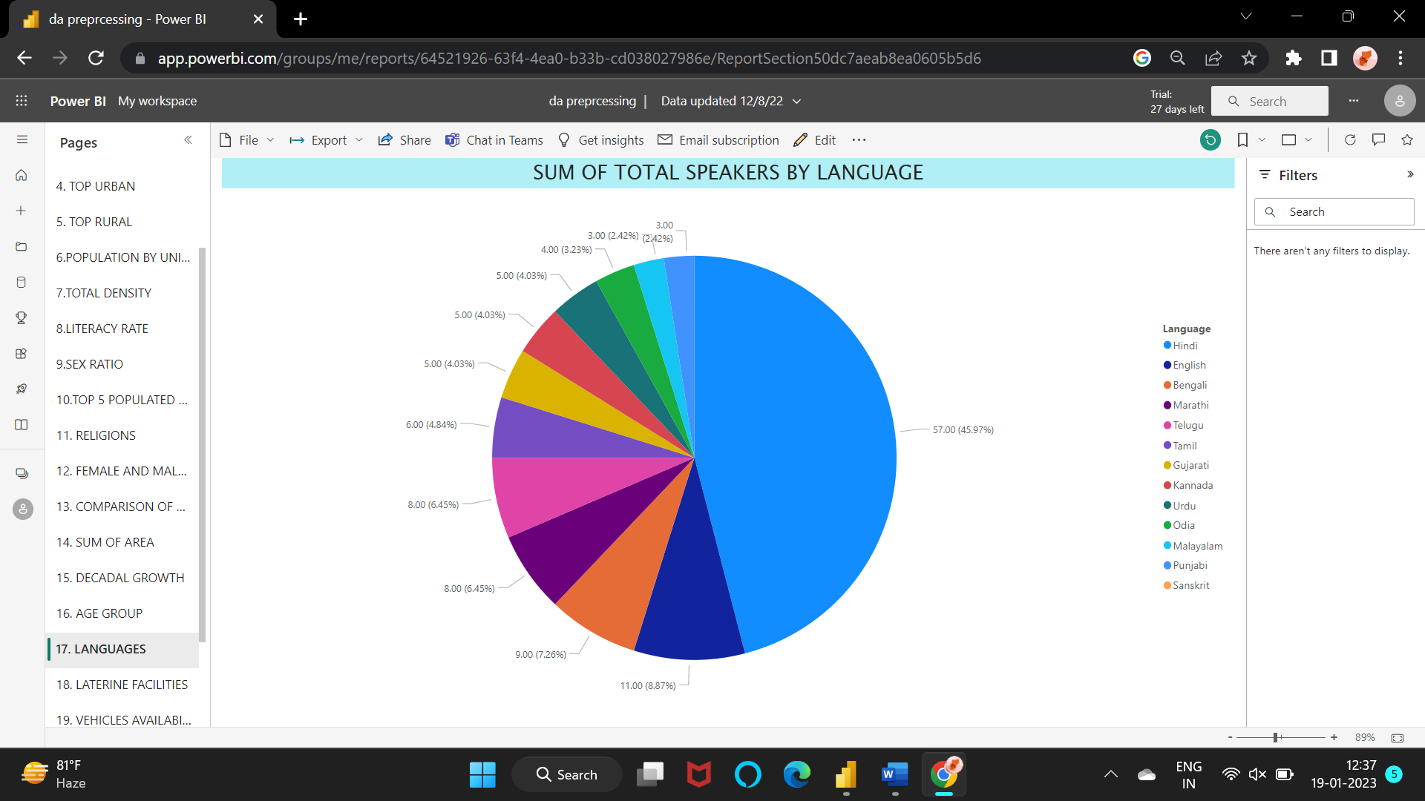

Figure 3.16 Sum of total speakers by language

17. Compare the availability and non-availability of latrine facilities in India.

STEPS:

Select the clustered column chart.

Add the columns ‘having latrine facilities’ and not having latrine facilities’ in the Y-axis.

OUTPUT:

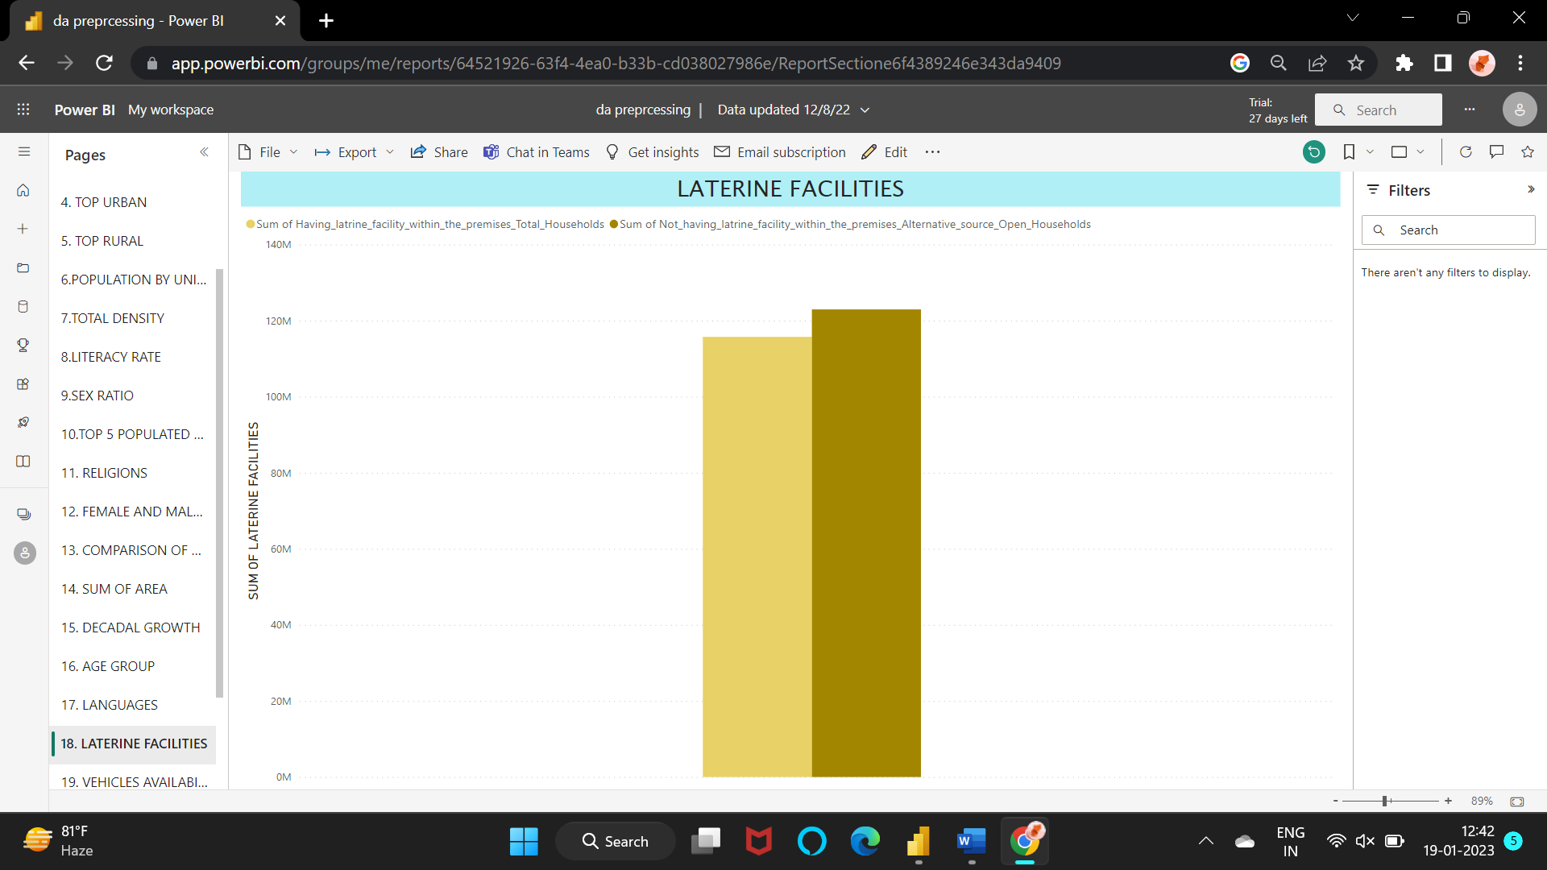

Figure 3.17 Latrine facilities

18. Which type of vehicle is highly available among all the households?

STEPS:

Select the clustered column chart and add the columns in the Y-axis.

OUTPUT:

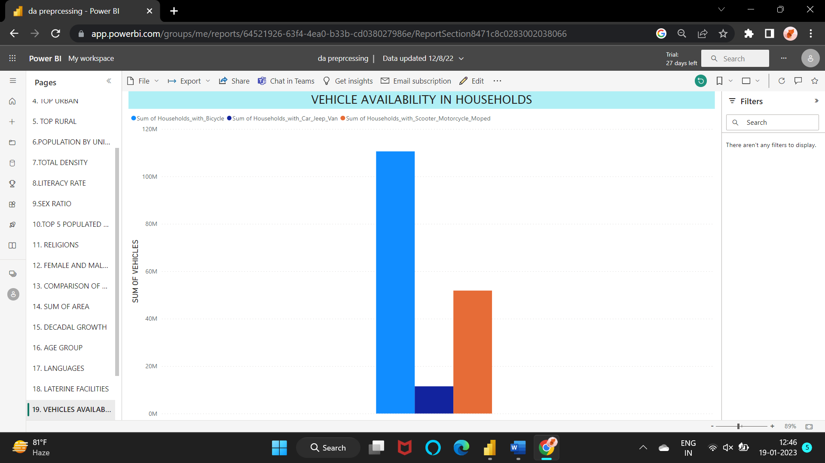

Figure 3.18 Vehicle availability in households

19. Classify the population according to the workers.

STEPS:

Insert a donut chart and add the required columns in the values field.

OUTPUT:

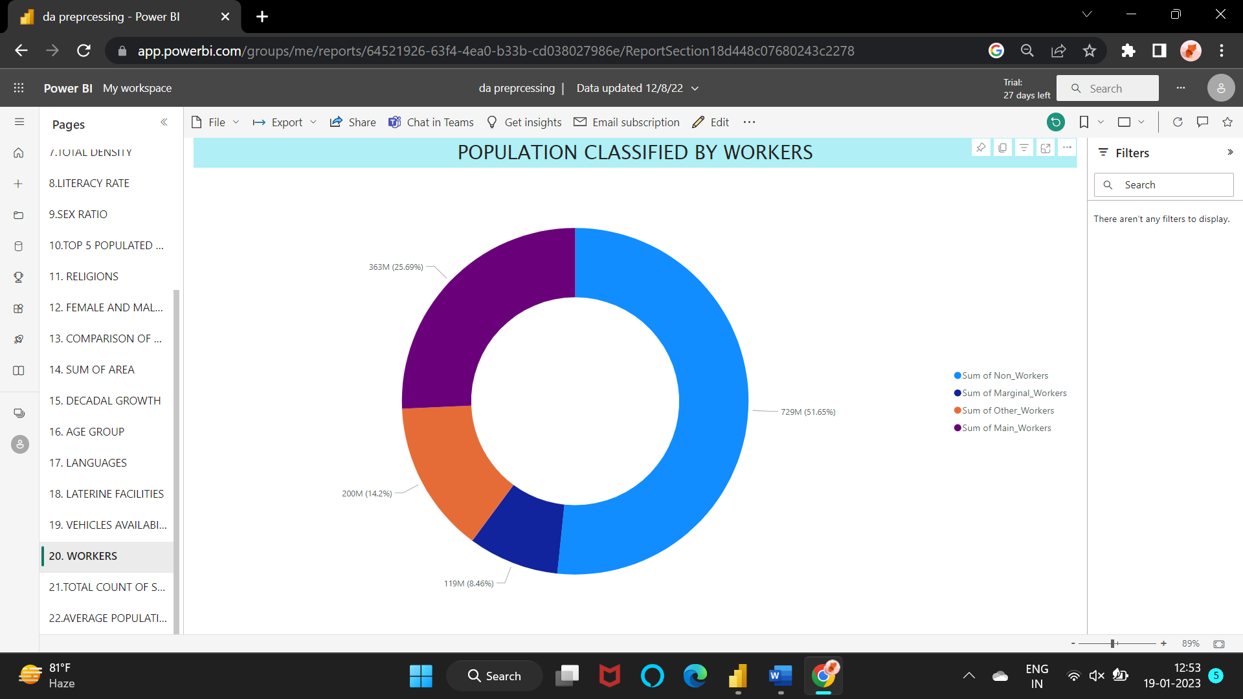

Figure 3.19 Population classified by workers

20. The total number of states and union territories?

STEPS:

Under the visualizations pane, select the card.

Under the fields drag and drop the ‘state name’ and set it to count.

OUTPUT:

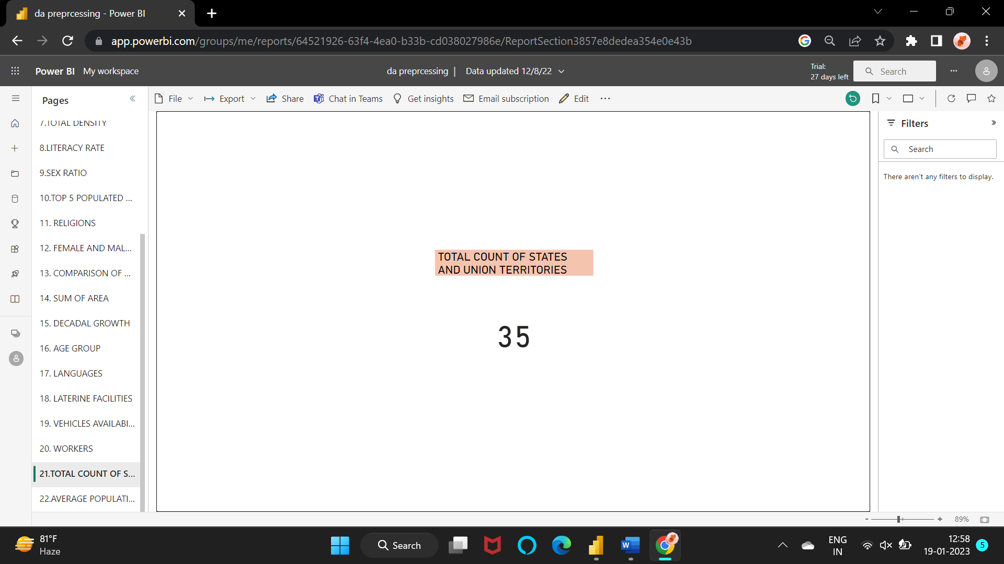

Figure 3.20 Total count of states union territories

21. what are the top 5 populated districts?

STEPS:

Select the clustered column chart under visualizations.

Add the district name in X-axis and the created measure in Y-axis.

POPULATED_DISTRICT = CALCULATE(MAX('education'[Population]),'population'[District name])

OUTPUT:

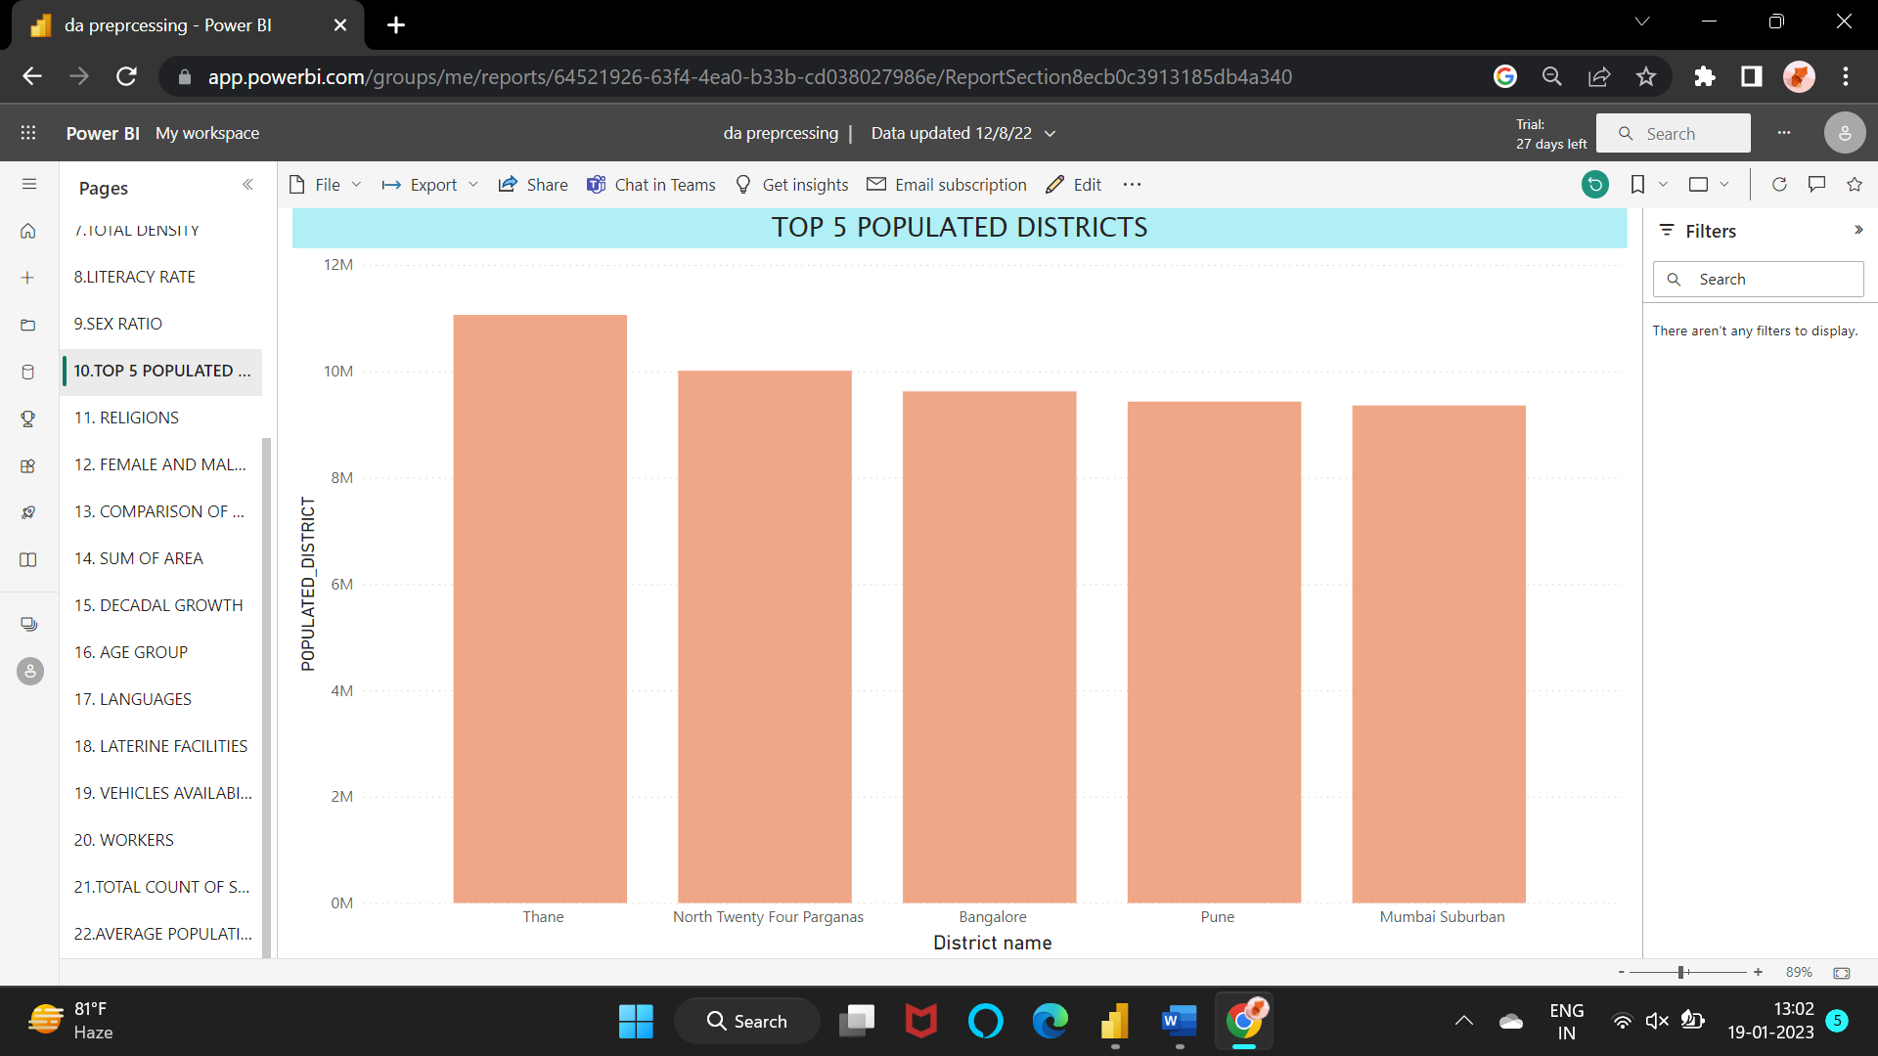

Figure 3.21 Top 5 populated districts

22. Average count of females and males?

STEPS:

Draw a pie chart and insert the column average of males and average of female columns in the values.

OUTPUT:

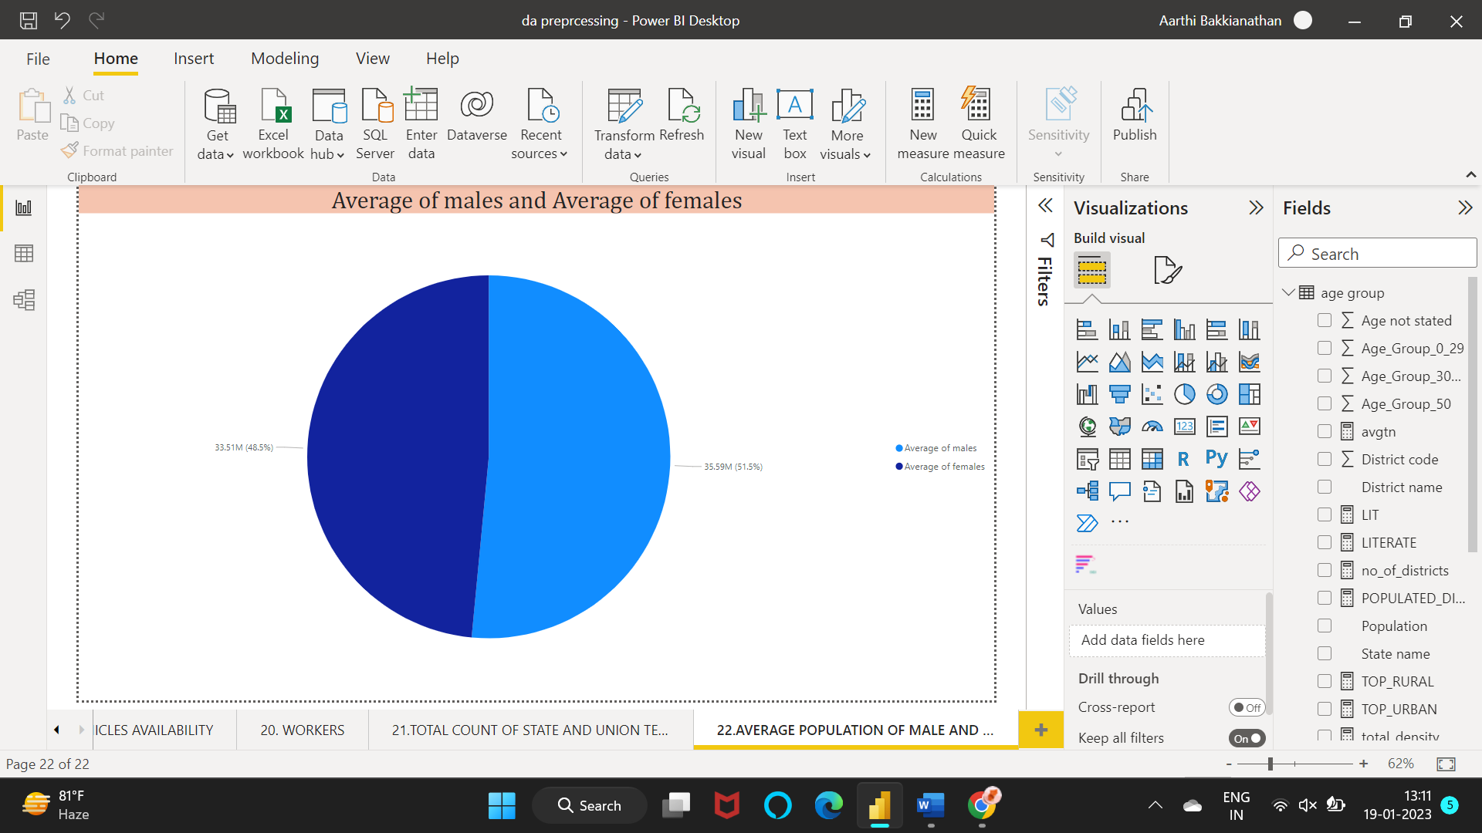

Figure 3.22 Average of count of males and female

## 3.3 INFERENCE

1. There are 640 districts in India according to the 2011 census.
2. 1210.9 M or 1.2 B is the total population of India according to the 2011 census.
3. The top 10 states with highest population are:

Uttar Pradesh – 200M

Maharashtra – 112M

Bihar – 104M

West Bengal – 91M

Andhra Pradesh – 85M

Madhya Pradesh – 73M

TamilNadu – 72M

Rajasthan – 69M

Karnataka – 61M

Gujarat – 60M

1. The highest urban population is in the state ‘Maharashtra’.

The lowest urban populated state is ‘Arunachal Pradesh’.

1. The highest populated rural state is ‘West Bengal’ and the lowest populated state is ‘Chandigarh’.
2. The rank of the union territories by their population is:
   * + 1. 1.NCT of Delhi – 3.66M
       2. 2.Chandigarh – 1.06M
       3. 3.Pondicherry – 0.95M
       4. 4.Dadra and Nagar haveli – 0.34M
       5. 5.Andaman and Nicobar Islands – 0.24M
       6. 6.Daman and Diu – 0.19M
       7. 7.Lakshadweep – 0.66M
3. The total density of India is 38,000 number of persons per square km.
4. The highest literacy rate is 94% which is in Kerala and the lowest literacy rate is 61.80% of Bihar state.
5. Kerala has the highest sex ratio of 1084 and the least sex ratio is 818 of Daman and Diu.
6. Hindus (79.8%) are highest in number whereas Jains (0.37%) are lowest in number in India.

Muslims (14.23%) are high in number when compared to Christians (2.3%).

0.24% of total population has not stated their religion.

1. Maharashtra is the state who has both the highest male and female worker when compared to all the other states and union territories. All the states and union territories has more male workers when compared to female worker. In Manipur the difference between the male workers and female workers are somewhat equal. Karnataka falls in the second place where the female workers are high next to Maharashtra.
2. The states/ union territories which have more urban population than rural are Chandigarh, Daman and Diu, Delhi, Goa, Lakshadweep, Pondicherry. Dadra and Nagar Haveli, Kerala, Maharashtra, Mizoram and TamilNadu have both the rural population and urban population at somewhat equal level.
3. Rajasthan has the highest sum of area that is 342239 km2 while goa has the least sum of area 3702 km2. Among the union territories Andaman and Nicobar Islands have the high of sum of area of 8249 km2 and Lakshadweep has the low sum of area of 32km2.
4. The decadal growth is more for Dadra and Nagar Haveli and less for Kerala.
5. The age group 0-29 is more when compared to others. In the second place is occupied by the age group 30-49. Then, comes the age group 50 and above. Some of them have not stated the age.
6. Hindi is the most spoken language among Indians whereas Punjabi and Malayalam are the least spoken language. English is the second most spoken language and Bengali falls in the 3rd place.
7. The household which has latrine facilities are less when compared to the households who doesn’t have latrine facilities.
8. The households which have bicycles are more when compared to others. The households which have car/jeep/van are very less in number. The households which have scooter/motorcycle are more when compared to household with car/jeep/van.
9. Non-workers are more, even after combining all the other types of workers. Among the different types of workers main workers are more and marginal workers are less.
10. the total count of states and union territories are 35.
11. The district which is more populated is Thane, located in Maharashtra state.
12. The average count of males (51.5%) is slightly higher than average of females (48.5%).

# CHAPTER 4

# CONCLUSION AND FUTURE WORK

This data is collected from GitHub which is of year 2011. So, all the above conclusions and analysis are based on that year. Some of the above analysis may have changed according to the new population analysis like the literacy rate has increased to 77.7% in 2022 according to the survey. Also, the population of India has increased from 1.2B to 1.4B that is an increase of 0.68%. India is the most populated country now beating China to second place. Half of the Indian population consists of people under 25.

# REFERENCES

[1] <https://github.com/shreerangscp/Indian-Population-Census-2011>

[2] <https://www.spec-india.com/live-bi-visualization/world-population-analysis-report>

[3] <https://nhm.gov.in/New_Updates_2018/Report_Population_Projection_2019.pdf>

[4] <https://testbook.com/blog/census-of-india-2011/>

[5] <https://pib.gov.in/newsite/PrintRelease.aspx?relid=71383>

[6] <https://www.civilsdaily.com/census-2011-the-basics-and-summary-of-important-findings/>

[7] https://en.wikipedia.org/wiki/2011_Census_of_India